***NETFLIX MOVIES AND TV SHOW ANALYSIS***



**Synopsis**

**1. Project Objectives**

The primary objective of this project was to analyses Netflix content to uncover patterns and trends in the types of shows and movies available on the platform. By leveraging a dataset sourced from Kaggle, the goal was to clean the raw data, conduct a thorough analysis, and present the findings visually using Power BI. Additionally, the project aimed to explore relationships between different variables, such as content type, release year, country of origin, and genre, to provide actionable insights for stakeholders.

Key objectives include:

* Cleaning the raw dataset to ensure accurate and meaningful analysis.
* Analysing content distribution across various genres, countries, and time periods.
* Visualizing trends and patterns using Power BI to make data-driven recommendations.

This project also seeks to highlight the importance of data-driven decisions in content production and acquisition strategies, particularly for streaming platforms like Netflix.

**2. Data Collection**

The data was collected from Kaggle, a popular platform for datasets and data science competitions. The dataset contains information on Netflix shows and movies, including key attributes such as title, director, cast, country, release year, and genre. The raw data required significant cleaning and preprocessing before any meaningful analysis could be performed.

The uncleaned data included inconsistencies such as missing values in important fields like director and cast, as well as formatting issues in columns like duration and date_added. Addressing these issues was a crucial first step in ensuring that the analysis would be reliable and reflective of actual trends on the platform.

The cleaned data, stored in the Excel workbook, represents the refined version of the original dataset, ready for analysis and visualization.

**3. Data Analysis Process**

The data analysis process involved several stages, beginning with data cleaning. This was done using Python in a Jupyter Notebook, where libraries such as pandas and NumPy were employed to handle missing values, standardize formats, and filter out irrelevant records.

Once the data was cleaned, the analysis moved to Power BI for visualization. Here, various charts and graphs were created to showcase key insights. For example, bar charts were used to illustrate the distribution of content types (Movies vs. TV Shows), while line charts tracked trends in content release over time. Geographical maps highlighted the concentration of content production in different countries.

This stage of the project emphasized the importance of visualization in making complex data more accessible and actionable. Power BI's interactive features allowed stakeholders to explore the data from multiple perspectives, ensuring that the findings were both comprehensive and engaging.

**4. Importance**

This project is significant as it provides a detailed analysis of Netflix’s content offerings, which can inform business strategies, content development, and consumer engagement initiatives. Streaming platforms like Netflix operate in a highly competitive environment, and data-driven insights can help them tailor their content to meet audience preferences, optimize regional offerings, and improve overall user satisfaction.

Moreover, understanding trends in content production—such as the rise of international TV shows or the prevalence of certain genres—can guide decisions on future content acquisitions and collaborations. This project highlights how data can be leveraged to create a competitive edge in the streaming industry.

**5. Scope**

The scope of this project extends beyond a simple analysis of Netflix content. It includes exploring relationships between various content attributes, such as the correlation between release year and genre popularity, or the impact of certain directors or actors on viewership trends.

The project also emphasizes the role of data visualization in communicating complex findings effectively. By utilizing Power BI, this analysis becomes not just a backend data process but a front-end tool for decision-makers in the industry.

The project’s scope can also be expanded in the future to include deeper analyses, such as predictive modelling to forecast content trends or sentiment analysis on user reviews to gauge audience reactions to different types of content.

**6. Software’s**

The project was conducted using several key software tools, each playing a critical role in different stages of the analysis:

* **Jupyter Notebook**: Used for data cleaning and preprocessing. Python libraries such as pandas, NumPy, and matplotlib were instrumental in transforming the raw data into a usable format.
* **Excel Workbook**: Excel was used for initial data exploration and basic cleaning, especially for handling smaller subsets of the data and ensuring proper formatting.
* **Power BI**: Power BI was used for data visualization and dashboard creation. Its interactive features made it an ideal choice for presenting the analysis in a way that stakeholders could easily interpret and explore further.
* **Python Packages and Libraries**: The project relied on Python's robust ecosystem for data science, with key libraries including pandas for data manipulation, NumPy for numerical operations, and matplotlib for basic visualizations.

**7. Hardware**

**Device name:** Game on.

**Processor:** 12th Gen Intel(R) Core (TM) i7-12700H 2.30 GHz

**Installed RAM:** 16.0 GB (15.6 GB usable)

**Device ID:** 244AA89F-3C2F-4D62-901D-3F0BFBB6F359

**Product ID:** 00342-43365-13608-AAOEM

**System type:** 64-bit operating system, x64-based processor

**INTRODUCTION**

***OVERVIEW:***

The "Netflix Movies and TV Show Analysis" project is aimed at examining the vast collection of media content available on Netflix to gain deeper insights into user preferences, trends in the types of shows or movies available, and other relevant factors such as release dates, genres, and ratings. This analysis provides a comprehensive understanding of Netflix's content library and how it caters to different demographics. By using cleaned datasets, visualization tools, and statistical methods, this project offers valuable findings that could be used for better content management, marketing strategies, and even for forecasting future trends in media consumption.

The analysis involves using data-cleaning techniques in Python and visualization tools like Power BI to explore the relationship between various content attributes. This includes factors such as the type of content (movie or show), genre, country of origin, and ratings. The project aims to give stakeholders a clearer picture of how Netflix's offerings vary across regions, audience types, and genres, ultimately guiding decision-making processes for both content creators and marketers.

***BACKGROUND:***

As streaming services continue to dominate the entertainment landscape, platforms like Netflix have emerged as key players in providing a wide variety of films and TV shows to viewers worldwide. With over 200 million subscribers across the globe, Netflix’s content library serves as an excellent dataset for analysing media consumption trends. Understanding how users interact with this vast array of content—ranging from dramas and comedies to documentaries and sci-fi—can provide valuable insights into audience preferences and platform performance.

This project is grounded in data analysis and aims to explore how factors such as country of origin, genre, and content rating correlate with the popularity of Netflix's titles. By cleaning and visualizing this data, we hope to create a model that explains or even predicts viewing habits across different demographics and timeframes.

***OBJECTIVES:***

1. **Analyse Genre Popularity**: One of the key objectives of this project is to explore the various genres available on Netflix and how they are distributed across different regions and demographics. By doing so, we can identify which genres are most popular globally and in specific markets.
2. **Examine Content Ratings**: Another critical goal is to analyse the ratings assigned to content by Netflix. This includes examining how ratings like "TV-MA," "PG-13," and others correspond to different types of content and how these ratings influence viewer choices.
3. **Understand Regional Preferences**: The project aims to explore how content from different countries performs on Netflix. By analysing country-specific trends, we can provide insights into how Netflix’s global platform tailors its offerings for specific regional audiences.
4. **Utilize Visualizations for Insights**: One of the essential objectives is to leverage Power BI to create insightful visualizations of the data. These visuals will not only help in explaining the key trends but also in making the results accessible to stakeholders who may not have a **technical background.**

***SCOPE OF THE PROJECT:***

**1)** **Analysis of Netflix's Data, Including Movies and TV Shows, Based on Key Attributes**: The primary focus of this project is to explore Netflix's vast library of movies and TV shows. Key attributes such as genre, country of origin, ratings, and duration will be analysed to gain insights into how different types of content are categorized and consumed. The analysis will help identify which genres or types of content (movies vs. TV shows) dominate the platform, and how these trends have evolved over time.

2) **Focus on Genre Distribution Across Different Countries and Regions**: A key aspect of this project is examining how Netflix distributes its content across different countries. For instance, the platform offers a range of genres (e.g., action, drama, romance) that may be more or less popular depending on the region. This analysis will help in understanding which countries show a preference for specific genres, helping Netflix tailor its content offerings accordingly.

3) **Study the Correlation Between Content Rating and Viewer Preferences**: Another major component is to study how Netflix’s content rating system (like "TV-MA," "PG-13," etc.) influences viewership and user preferences. This correlation can provide insights into the types of content different age groups or audience segments prefer. For example, if TV-MA content is more popular in certain regions, Netflix can use this information to strategize future content production.

4) **Use of Python for Data Cleaning and Transformation**: Python will be heavily used to clean and transform the dataset. This includes handling missing values, converting columns to appropriate data types (such as transforming date strings into actual date objects), and formatting categorical data. Python's efficient libraries like Pandas and NumPy allow for powerful data manipulation, ensuring that the dataset is structured correctly for analysis and visualization.

5) **Leverage Power BI for Data Visualization and Interpretation**: Once the dataset is cleaned, Power BI will be used to visualize the data. The tool allows for the creation of interactive dashboards and visual reports that make it easier to interpret the findings. With Power BI, it is possible to create charts, graphs, and maps that can show, for instance, how a certain genre is distributed across different countries or how ratings impact viewership.

6) **Provide Actionable Insights for Content Creation and Marketing Strategies**: The analysis will result in actionable insights that can help Netflix make informed decisions regarding content creation and marketing. For example, if the analysis shows that certain genres perform exceptionally well in particular regions, Netflix could allocate more resources to producing similar content for those markets. Similarly, insights about rating preferences could guide marketing efforts to target specific audience demographics.

7) **Prediction of Content Success Based on Historical Data**: By analysing historical data from Netflix, this project aims to predict the potential success of future content. Factors like genre, country of origin, and rating will be used to build models that can forecast whether a particular type of show or movie will be successful based on past performance. This predictive analysis can assist Netflix in making data-driven decisions for new content investments.

8**) Recommendation system:** It is optional to investigate the creation of a rating-based recommendation system.

***INCLUSIONS:***

1) **Analysis of Content Genres**: The project will include an in-depth analysis of the different genres available on Netflix. This will involve categorizing content by genre (e.g., drama, action, comedy) and examining the distribution of each genre on the platform, both globally and regionally.

2) **Review of Content Ratings**: The analysis will also include an examination of Netflix’s rating system. This will involve mapping ratings such as "TV-MA," "PG-13," etc., and analysing how these ratings impact viewer behaviour and content distribution across different regions.

3) **Regional Content Analysis**: The analysis will explore how content from different countries and regions performs on the platform. This will help understand which regions prefer which types of content, providing insights for Netflix to localize its content offerings.

4) **Visual Representation Using Power BI**: The project will include creating various visual representations of the data using Power BI. This will help in identifying trends, such as the popularity of certain genres or ratings over time, and presenting these findings in an easy-to-understand format.

5) **Use of Python Libraries for Data Cleaning and Preparation**: Python libraries like Pandas and NumPy will be used to clean and prepare the dataset for analysis. This includes handling missing data, converting data types, and applying transformations to make the dataset usable for analysis and visualization.

***EXCLUSIONS:***

1) **No Analysis of User Behaviour Outside of Available Content Data**: The scope of this project is limited to analysing the available content data. This means that we are not examining individual user behaviour or viewing habits beyond the information provided in the dataset. For instance, we are not analysing how often specific users watch certain types of content.

2) **No Review of Netflix's Pricing or Subscription Models**: This project does not include any analysis of Netflix’s pricing strategies or subscription tiers. While these factors may influence content consumption, they are beyond the scope of this analysis, which is focused solely on the content available on the platform.

3) **Excludes Qualitative Analysis Such as Reviews or Viewer Comments**: The project will not involve any qualitative analysis, such as examining user reviews or comments about the content. This is because the focus is on quantitative data, such as genre, rating, and regional distribution, rather than subjective opinions from viewers.

***TECHNOLOGY:***

This project relies on two main technologies: Python and Power BI. Python is used primarily for data cleaning and pre-processing. Various libraries like Pandas and NumPy have been employed for data manipulation. Python's flexibility allows for efficient handling of the dataset, which includes several thousand entries covering multiple attributes like genre, type, rating, and more.

Power BI, a business analytics tool, is used to visualize the cleaned data. The data visualizations provide insights into trends and relationships within the Netflix dataset, making it easier for stakeholders to understand the results without having a technical background. Power BI's dashboard capabilities also enable the presentation of multiple visualizations simultaneously, offering a holistic view of the data.

***PYTHON:***

• Python is a pillar of the data science and analytics community, with a rich and diverse ecosystem of libraries and tools.

• Pandas is a data manipulation and analysis library that is used extensively in our analysis. It plays a crucial role in the preprocessing and data cleaning phases. Because of Pandas' proficiency with a variety of data structures, we can effectively clean, restructure, and analyse the Amazon Prime dataset.

• It is a valuable tool that can easily navigate through the complexities of data cleaning and lay the foundation for insightful analyses that reveal details of content dynamics on streaming platforms thanks to its extensive functionality and intuitive syntax.

• Pandas is a great tool for handling missing data; it uses smart functions like dropna() and fillna() to handle missing values and maintain the integrity of the dataset.

• Pandas offers filtering and sorting tasks simple, making it possible to extract relevant subsets and arrange data to make further analysis easier.

• Python is essential for creating a recommendation model that takes into account the popularity of the content. We implement a recommendation algorithm that takes into account the popularity of genre, utilizing the ease of use and efficiency of Python.

• By making recommendations for content based on its wider acceptance and appeal among viewers, this model improves the user experience on the platform.

***LIBRARY USED:***

1) **Pandas**: This library was pivotal for data cleaning and transformation. Pandas’ DataFrame structure allowed for easy manipulation and analysis of the dataset, including filtering, sorting, and reshaping data.

2) **NumPy**: NumPy was used alongside Pandas for handling numerical operations. Its compatibility with Pandas made it the ideal library for performing statistical operations, such as filling missing values with means and handling large arrays efficiently.

***MEANING OF COSINE SIMILARITY BETWEEN VECTORS***

Vectors: In this case, each title is represented as a vector in a high-dimensional space. The dimensions of this space refers to the unique words present in the genre information across all titles.

TF-IDF Representation: The TF-IDF representation is a numerical representation of the genres for each title. It takes into account both the frequency of terms (TF - Term Frequency) and their importance across the entire dataset (IDF - Inverse Document Frequency).

Cosine Similarity: Cosine similarity is a measure of similarity between two vectors. It calculates the cosine of the angle between them, indicating how closely the vectors align. The range of cosine similarity is [-1, 1], where 1 means the vectors are identical, 0 means they are orthogonal (no similarity), and -1 means they are diametrically opposed.

***In the context of my recommendation system:***

• A higher cosine similarity between two titles' vectors indicates a higher similarity in terms of their ratings information.

• The recommendation system uses this similarity measure to identify titles with similar ratings to the input title, helping to suggest related movies or TV shows.

• Cosine similarity is a way to quantify the similarity between vectors, and in the recommendation system, it helps identify titles with ratings profiles.

***POWER BI:***

• Python's ability to manipulate and analyse data is enhanced by Power BI, which is my preferred tool for generating interesting and interactive visualizations.

• Microsoft's Power BI is a business analytics tool that enables users to easily and effortlessly visualize and share insights from their data.

• One of Power BI's main benefits is its intuitive interface, which makes it possible to create impressive visualisations without requiring a lot of coding knowledge. Because of its accessibility, stakeholders with different technical backgrounds can interact with it and gain valuable insights from the analyses.

• Python and Power BI work together effectively to create an efficient analytical workflow that combines Power BI's visualization capabilities with Python's strengths in advanced analytics and data cleaning.

• A range of chart formats, including bar charts, line charts, and heatmaps, are used to display trends in the popularity of content, the distribution of genres, and other important metrics. The interactive features of Power BI facilitate a dynamic and exploratory data analysis process by allowing stakeholders to explore further into particular aspects of the data.

***BENEFITS:***

• Power BI and Python work together to maximize the benefits of each tool's a collaborative effort.

• The complex tasks of data cleaning and recommendation model development are handled by utilizing Python's versatility and effectiveness in data manipulation and advanced analytics.

• Meanwhile, the analytical results are transformed into captivating visualisations that are easily understood and interpreted by a wide range of audiences by Power BI's user-friendly interface and dynamic features.

• Through the collaborative use of Python and Power BI, the project is able to handle large datasets and create customized visuals. It also makes efficient data exploration and descriptive analysis possible.

• The open-source Python community and the user-friendly visualization capabilities of Power BI work together to create a powerful analytical environment that makes it possible to explore the Amazon Prime movie and TV show dataset in a comprehensive and perceptive way.

***METHODOLOGY:***

1. **Title**:
   * **Description**: This column contains the name of each movie or TV show available on Netflix.
   * **Role in Analysis**: Titles are unique identifiers for the content. While not analysed directly, titles help track specific content when generating visualizations or analysing trends for individual shows or movies.
2. **Genre**:
   * **Description**: This column contains information about the genre of each show or movie (e.g., Drama, Comedy, Action).
   * **Role in Analysis**: The genre helps categorize content and allows you to analyse the popularity or distribution of different genres on Netflix. For example, you can study how many shows belong to the "Drama" genre versus "Action" and analyse genre trends across countries or regions.
3. **Country of Origin**:
   * **Description**: This column specifies the country or region where the content was produced (e.g., USA, India, United Kingdom).
   * **Role in Analysis**: The country of origin is useful for regional analysis, helping you understand which countries produce the most content on Netflix and which countries’ content is most consumed. You can also analyse genre preferences by country.
4. **Content Rating**:
   * **Description**: This field contains the rating assigned to each show or movie, such as "TV-MA" (for mature audiences), "PG-13", or "R" (restricted).
   * **Role in Analysis**: Content ratings are crucial for analysing how different types of viewers consume content. For example, you can analyse whether mature-rated shows are more popular in specific regions or whether family-friendly content is more widely available in certain countries.
5. **Date Added**:
   * **Description**: This column shows when the movie or show was added to Netflix's library.
   * **Role in Analysis**: The date added allows you to analyse trends over time. For example, you can see whether certain genres became more popular over specific periods or how frequently new content was added to the platform.
6. **Year Added**:
   * **Description**: Extracted from the "date added" column, this indicates the year the content was added to Netflix.
   * **Role in Analysis**: By breaking down the date into specific years, you can study how Netflix’s library has grown or changed over time. You can also analyse how the release of new shows in a particular year impacts content consumption trends.
7. **Duration**:
   * **Description**: This column provides the duration of the content, typically in minutes for movies or in seasons for TV shows (e.g., "90 min" or "2 Seasons").
   * **Role in Analysis**: Duration can be used to analyse the distribution of short versus long-form content. For example, you can study whether longer movies are more popular or if shows with more seasons attract higher viewership. In your Python code, the string "min" was extracted to convert the duration into a numerical value (for movies) to make it easier to analyse.
8. **Director**:
   * **Description**: This column lists the director of each movie or TV show.
   * **Role in Analysis**: While this may not be a primary focus of your analysis, the director information can be useful for advanced analysis, such as studying trends for specific directors or comparing content from well-known directors.
9. **Cast**:
   * **Description**: This column provides information on the actors involved in the movie or show.
   * **Role in Analysis**: Similar to the director field, the cast can be used for detailed analysis. For example, you could analyse whether shows or movies with specific popular actors perform better than others.
10. **Listed In**:
    * **Description**: This field contains the category under which the content is listed on Netflix, such as "Comedies," "Dramas," or "Action & Adventure."
    * **Role in Analysis**: This attribute is another way to categorize content beyond just genres. It allows you to analyse what type of content Netflix is promoting and how these categories perform globally or regionally.

***PYTHON CODE***

This Python script performs data cleaning and transformation on a Netflix dataset, which is stored in a CSV file. It uses pandas and NumPy libraries for data manipulation. Let’s go through the code step by step, explaining each function and operation.

***Step 1: Importing Libraries and Reading the Data***

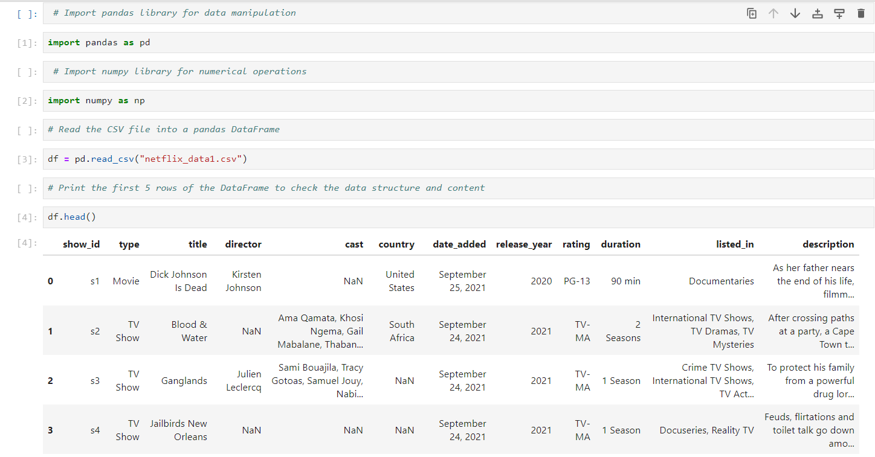

Here, the necessary libraries are imported: pandas for handling the data, and NumPy for numerical operations. The file_path variable stores the path of the Netflix dataset CSV file. The pd.read_csv() function reads the CSV file into a pandas DataFrame (df), which is a table-like **data structure where** each column can hold different types of data. The print(df.head()) command prints the first 5 rows of the DataFrame, giving a quick view of the dataset to check the structure and content.

***Step 2: Dropping Unnecessary Columns***

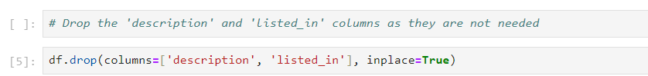

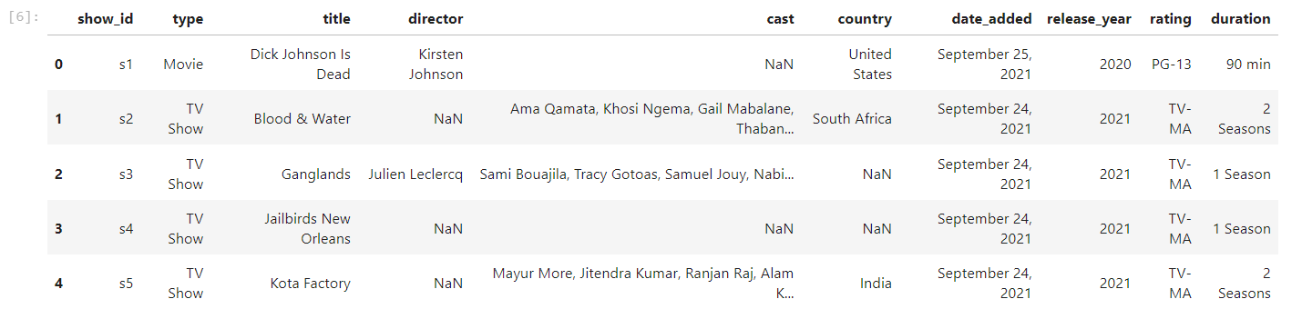

This line removes the columns **'description'** and **'listed_in'** from the DataFrame, as they may not be needed for further analysis. The **drop()** function is used to remove these columns by specifying them in the **columns** parameter. By setting **inplace=True**, the original DataFrame (df) is modified directly, meaning there’s no need to reassign the result to a new variable. This step is essential to reduce the dataset's complexity, making it easier to focus on relevant information.

***Step 3: Converting Dates and Extracting Components***

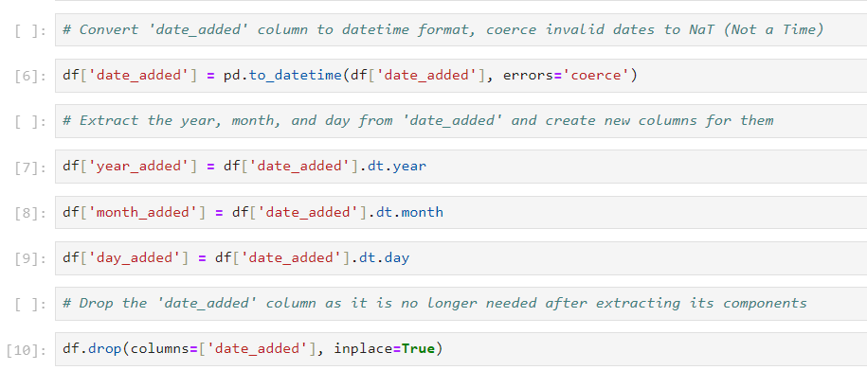

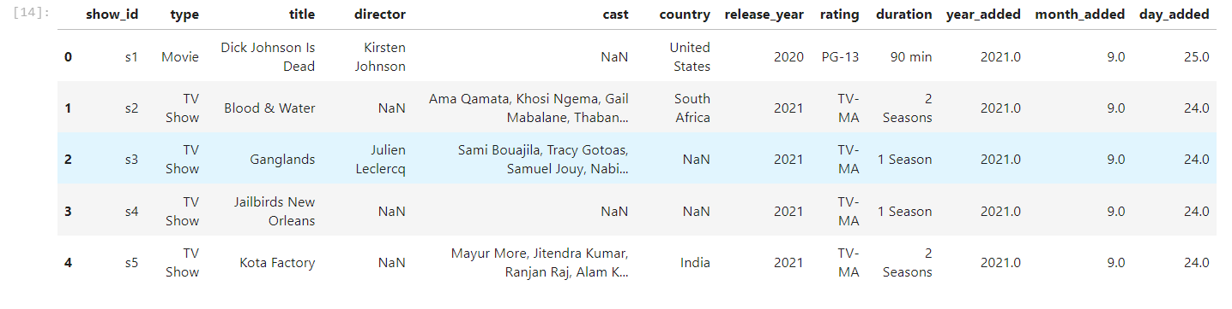

The column **'date_added'** contains dates in string format, which need to be converted to a datetime format for easier manipulation. The **pd.to_datetime()** function performs this conversion, and **errors='coerce'** ensures that invalid date entries are set to **NaT** (Not a Time), avoiding errors.

Once converted, the code extracts the year, month, and day components from the **'date_added'** column using **.dt.year**, **.dt.month**, and **.dt.day**. These components are stored in new columns: **'year_added'**, **'month_added'**, and **'day_added'**. Finally, the original **'date_added'** column is dropped as its components have been extracted and are now individually accessible for analysis.

***Step 4: Mapping Ratings to Numeric Values***

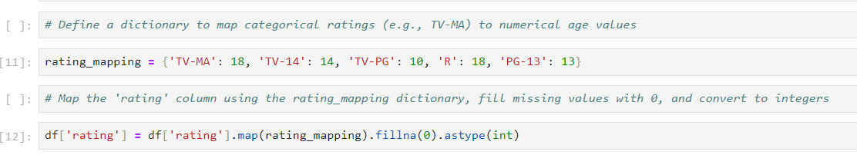

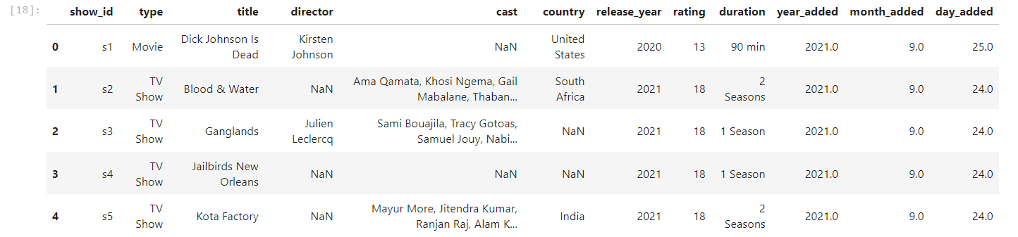

This step converts the categorical rating values (like **'TV-MA'** or **'PG-13'**) into numerical values for easier comparison and analysis. The **rating_mapping** dictionary specifies these mappings: for example, **'TV-MA'** is mapped to **18**, indicating that the content is appropriate for viewers aged 18 and older.

The **map()** function applies this dictionary to the **'rating'** column, replacing the categorical values with the corresponding numbers. If any ratings are missing or do not match the dictionary, **fillna(0)** replaces them with **0** to indicate that the rating is unavailable. Finally, **.astype(int)** ensures that the resulting values are integers. This transformation is crucial for performing numeric operations like filtering or aggregating data by age appropriateness.

***Step 5: Extracting Numeric Duration***

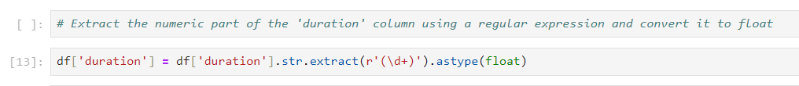

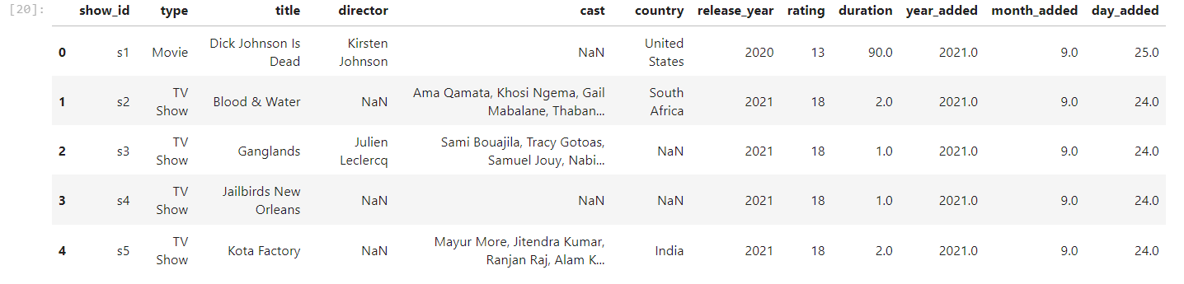

The **'duration'** column, which likely contains strings like **'120 min'** or **'2 Seasons'**, needs to be converted into a numeric format. The **str.extract(r'(\d+)')** function uses a regular expression (r'(\d+)') to extract the numeric part of the duration, ignoring any text. This expression captures one or more digits (represented by \d+) and ignores everything else.

Once the numeric part is extracted, **.astype(float)** converts the values to floating-point numbers. This transformation ensures the **'duration'** column can be used for numeric calculations, such as averaging the length of content.

***Step 6: Converting Specific Columns to Uppercase***

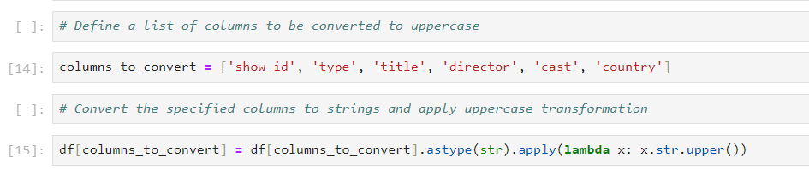

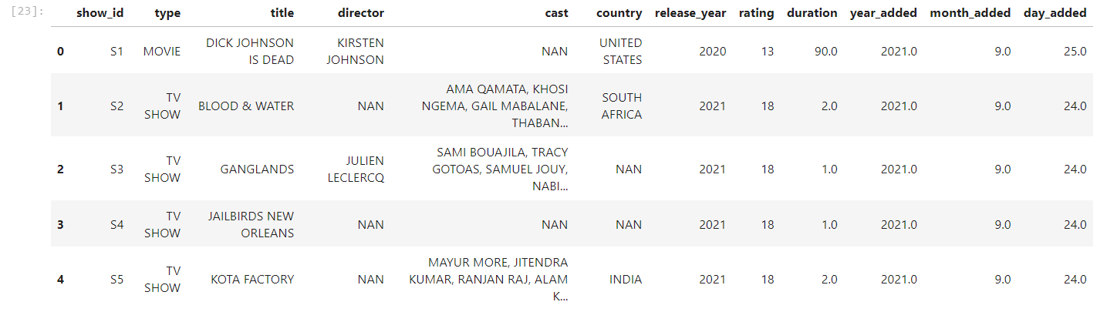

This code block targets specific columns such as **'show_id'**, **'title'**, **'director'**, **'cast'**, and **'country'** to ensure all values are converted to uppercase strings. First, **.astype(str)** ensures that all entries in these columns are treated as strings. Then, the **apply()** function is used to apply a lambda function, which converts the text to uppercase via **x.str.upper()**.

This step standardizes the text data, making comparisons and searches case-insensitive. For example, **'usa'** and **'USA'** are now treated as the same value, avoiding inconsistencies when analyzing or filtering the data.

***Step 7: Handling Missing Values in Numeric Columns***

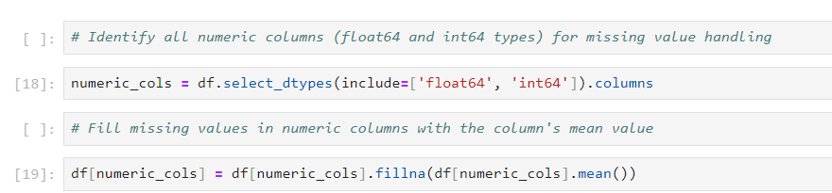

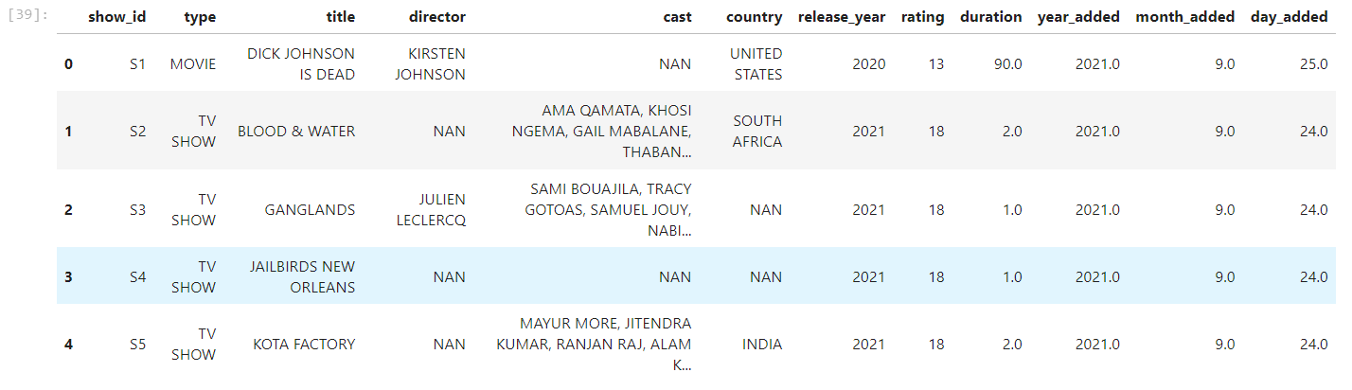

This code identifies the numeric columns in the DataFrame using **select_dtypes(include=['float64', 'int64'])**, which selects all columns with data types **float64** and **int64** (i.e., numeric columns).

For these numeric columns, the **fillna()** function replaces any missing values (NaNs) with the mean of the column. This approach ensures that missing data is filled with reasonable values based on the dataset's overall trends, preventing errors during analysis or calculations.

***Step 8: Handling Missing Values in Categorical Columns***

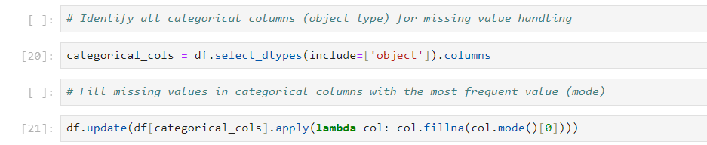

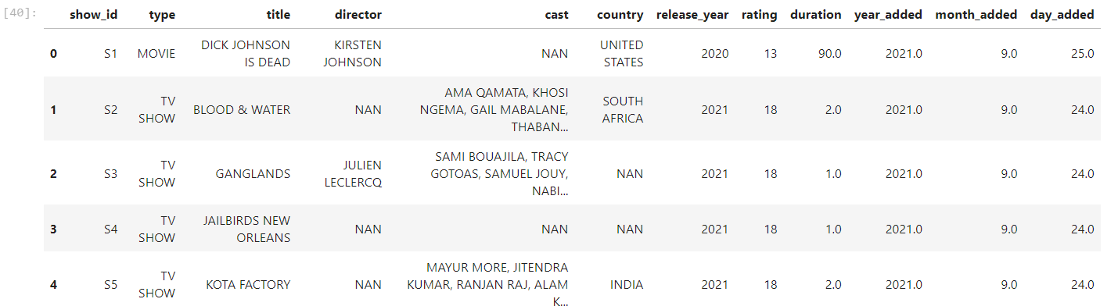

This step deals with missing values in categorical columns (text-based data). First, **select_dtypes(include=['object'])** selects all columns that contain object data types (typically used for strings). For each categorical column, **fillna(col.mode()[0])** replaces missing values with the column's most frequent value (its mode).

By using the mode, missing values are filled in a way that reflects the most common occurrence in the dataset, making it a reasonable and intuitive choice for handling missing data in categorical fields.

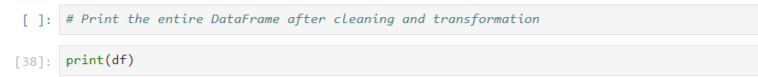

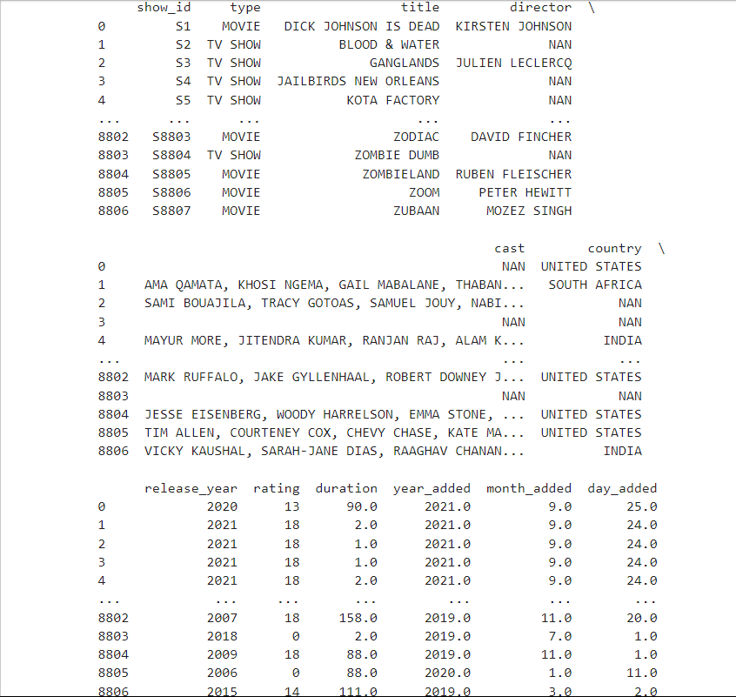

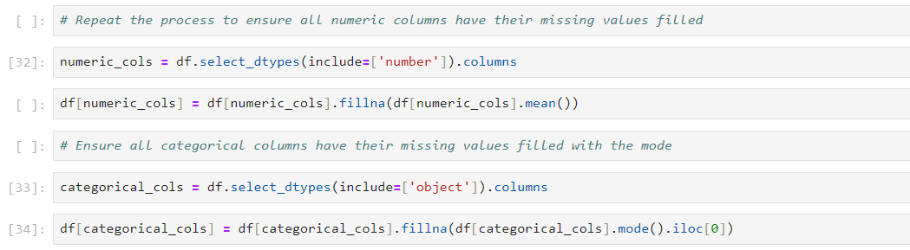

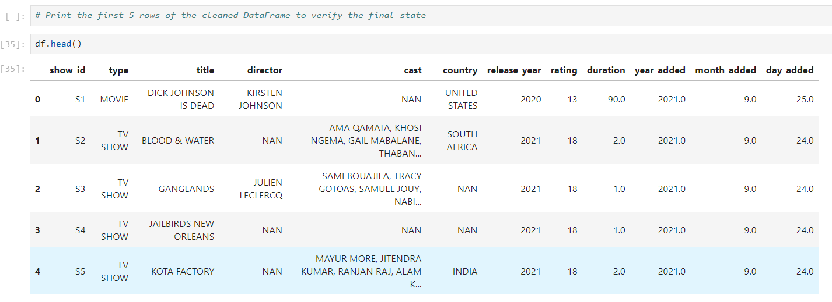

***Step 9: Final Cleaning and Saving the Data***

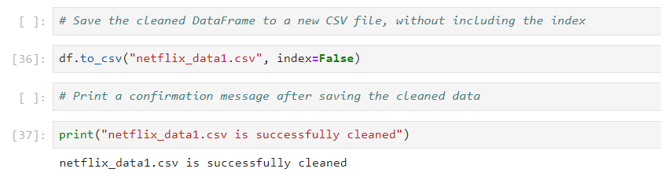

Finally, the cleaned and transformed DataFrame is saved as a new CSV file at the specified path. The df.to_csv() function writes the DataFrame to a CSV file, and index=False ensures that row indices are not included in the saved file. The print() statement confirms that the cleaned data has been saved successfully.

The excel sheet data is now saved in the folder of the Jupyter where the file was created.

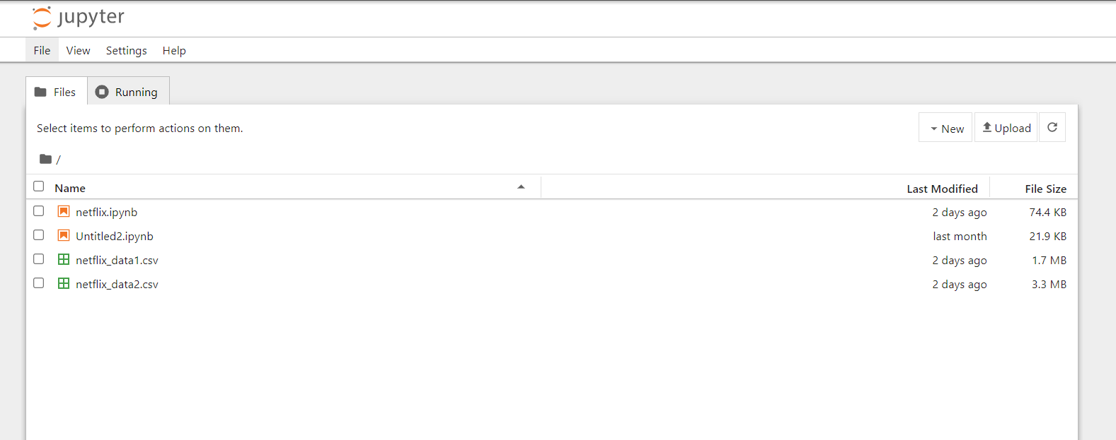

Click on the box of ‘netflix_data.2’ and there will be option on the above panel , click ‘DOWNLOAD’ option and the data will be saved in your device.(in the downloads section of This PC)

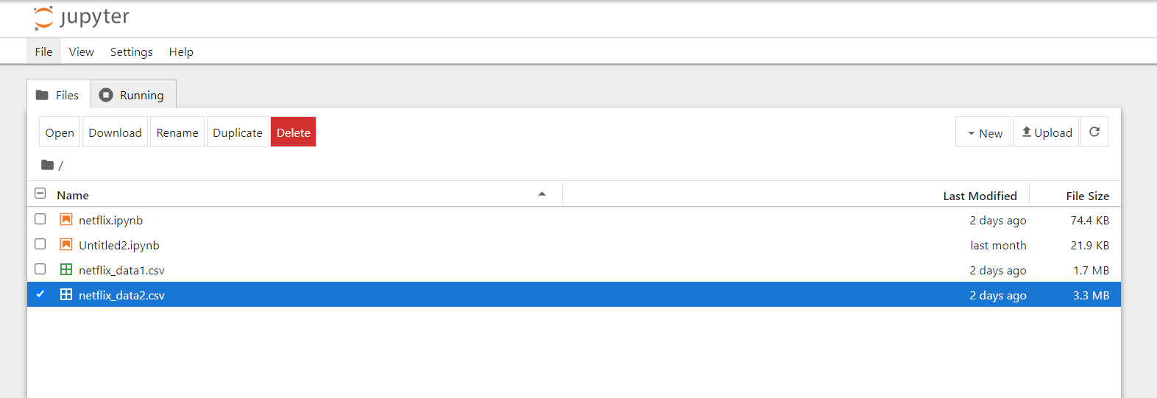

***VISUALISATION IN POWER BI***

Power BI is a powerful business analytics tool developed by Microsoft that enables users to visualize and share insights from their data in an interactive and intuitive manner. It allows for the seamless connection to various data sources, transforming raw data into rich visuals like dashboards, charts, and reports. With its easy-to-use interface, Power BI helps users create custom reports, explore their data through drill-down features, and uncover trends or patterns that might otherwise be difficult to see.

One of the key advantages of Power BI is its ability to handle real-time data, offering businesses the opportunity to monitor key metrics as they change and receive timely updates on performance. It also integrates well with other Microsoft services like Excel, Azure, and Office 365, enhancing collaboration and making it a flexible solution for businesses of all sizes. Whether used for sales performance tracking, financial analysis, or operational monitoring, Power BI provides a comprehensive platform for data-driven decision-making.

LOADING THE ‘netflix_data.2’ TO POWER BI

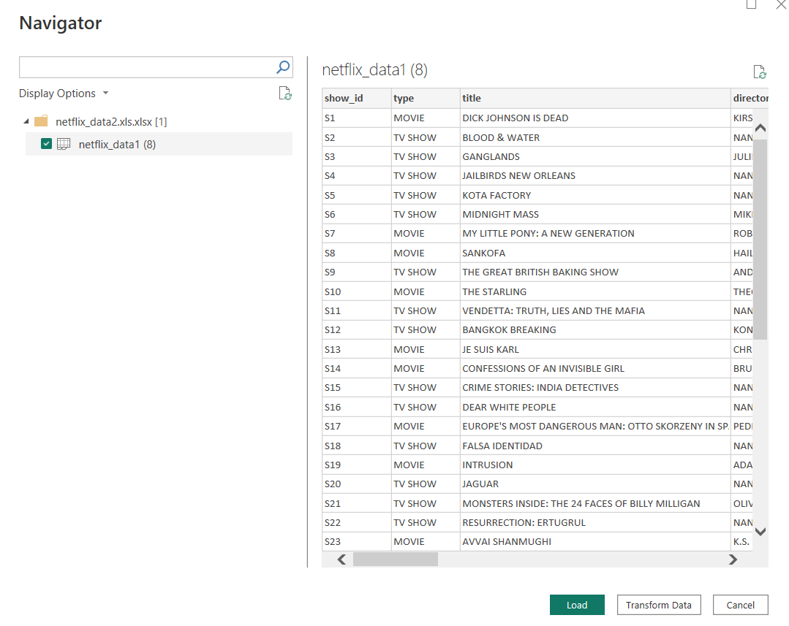

CLICK ON ‘LOAD’ TO CONTINUE,

THE COLUMNS OF THE SHEET WILL NOW BE VISIBLE AT THE CORNER.

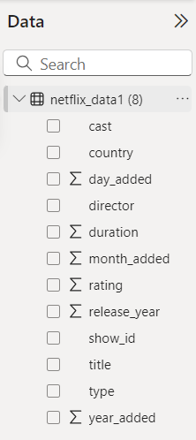

***I HAVE MADE VISUALISATIONS USING POWER BI FOR REPRESENTATION OF THE DATA.***

***VISUALISATION 1)***

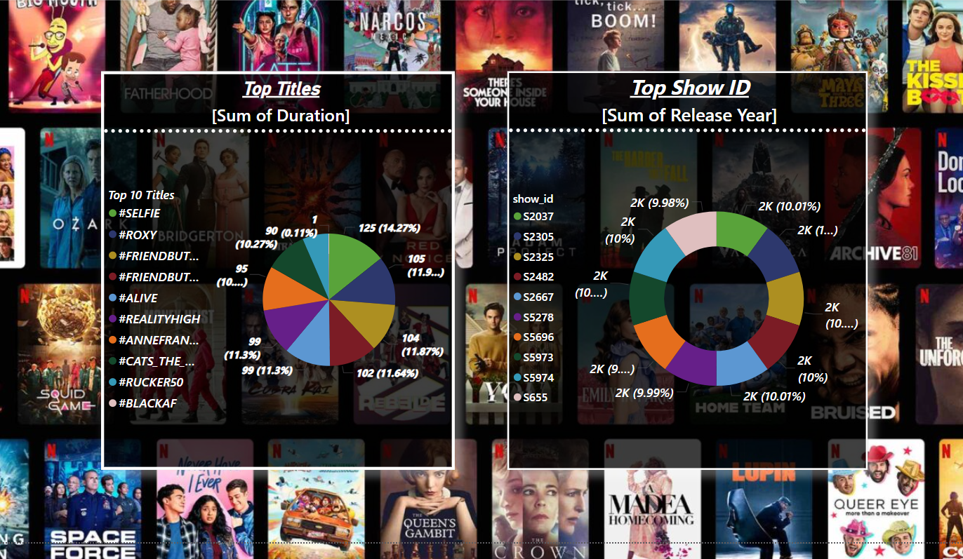

**Left Donut Chart (Top Titles): This chart represents the top 10 Netflix titles based on the sum of their duration (likely viewing time or total episodes/minutes watched). Each segment of the donut represents a specific title, labeled with its name, duration percentage, and count (which could represent either total views, episodes, or minutes watched). The motive of this chart is to show which titles have dominated in terms of viewer engagement, helping understand user preferences or content success based on total watch time.**

**Right Donut Chart (Top Show IDs): This chart showcases the Top Show IDs based on the sum of release year. While this is less straightforward, it might be aggregating the release years of shows under specific IDs to provide insight into the relative recency or legacy of content on Netflix. It gives a visual breakdown of which shows (by their unique IDs) are most prominent based on when they were released, possibly showing how newer or older shows contribute to viewership.**

In summary, the visualizations provide clear insights into the **viewing behavior of Netflix users**, showing which titles and show IDs are most significant across two metrics. This analysis helps Netflix or other content providers strategize content delivery, as well as informs data-driven decisions around future content offerings.

***VISUALISATION 2)***

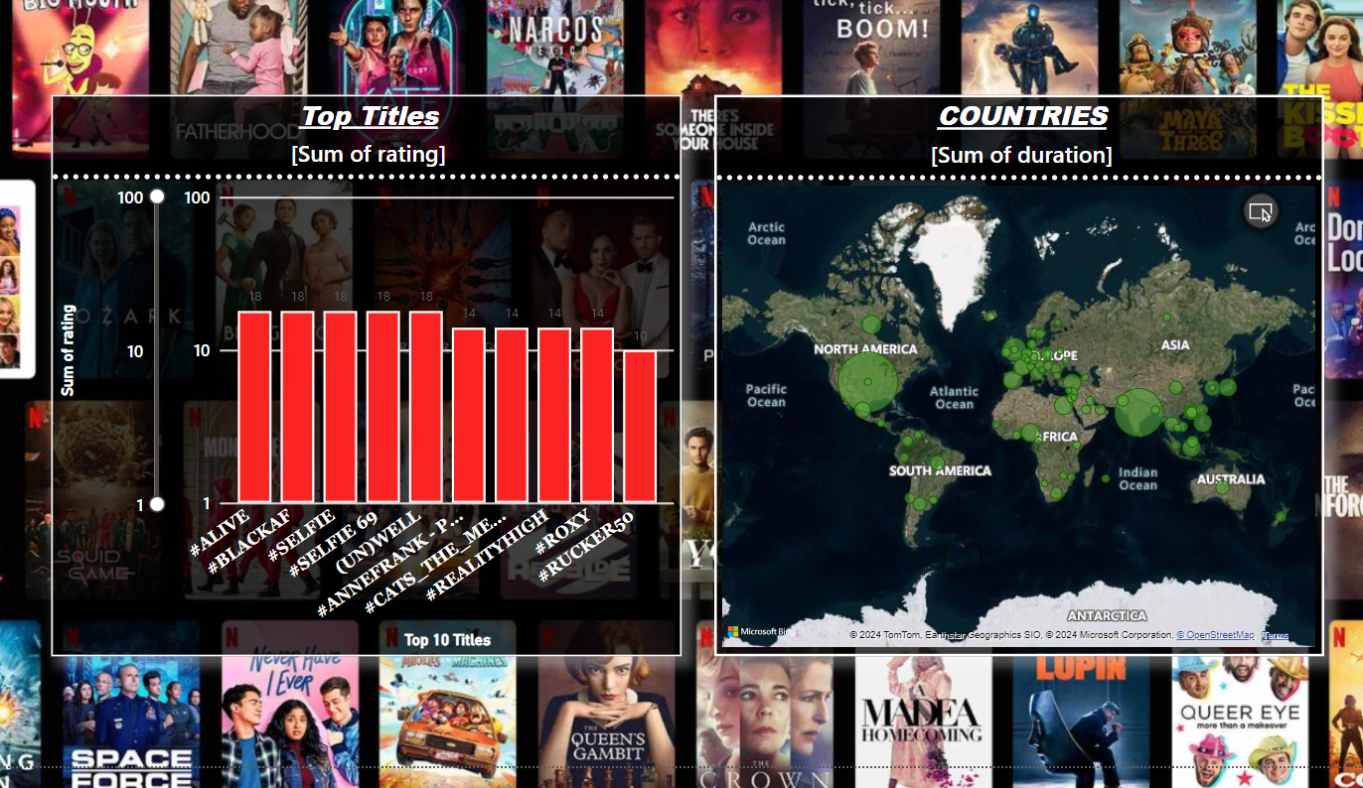

In the visualization, there are two distinct charts: a **Bar Chart** on the left and a **Map Chart** on the right. The **Bar Chart** is titled "**Top Titles**" and represents the **Sum of Rating** for each of the top-rated Netflix shows. Titles such as **#ALIVE**, **#BLACKAF**, and **#SELFIE** dominate the chart, with the bar height indicating their total rating sum. The purpose of this bar chart is to visually compare the ratings of different Netflix shows, highlighting which titles have garnered the most attention or highest feedback from viewers. The bars are color-coded in red, providing a clear distinction between the top 10 titles.

On the right is a **Map Visualization**, showing **Countries** by the **Sum of Duration**, with green bubbles representing different countries across the world. The size of each bubble indicates the total viewing duration of Netflix content in that region, with larger bubbles signifying higher engagement. This map provides a geographical breakdown of where Netflix content is consumed the most, helping to identify strong market regions or countries with high viewer engagement. The use of a map chart helps offer insights into regional preferences and content consumption patterns across the globe. This visualization can be used to analyze Netflix's global reach and which countries have the highest watch time, thus guiding strategic decisions for content localization or market focus.

***VISUALISATION 3)***

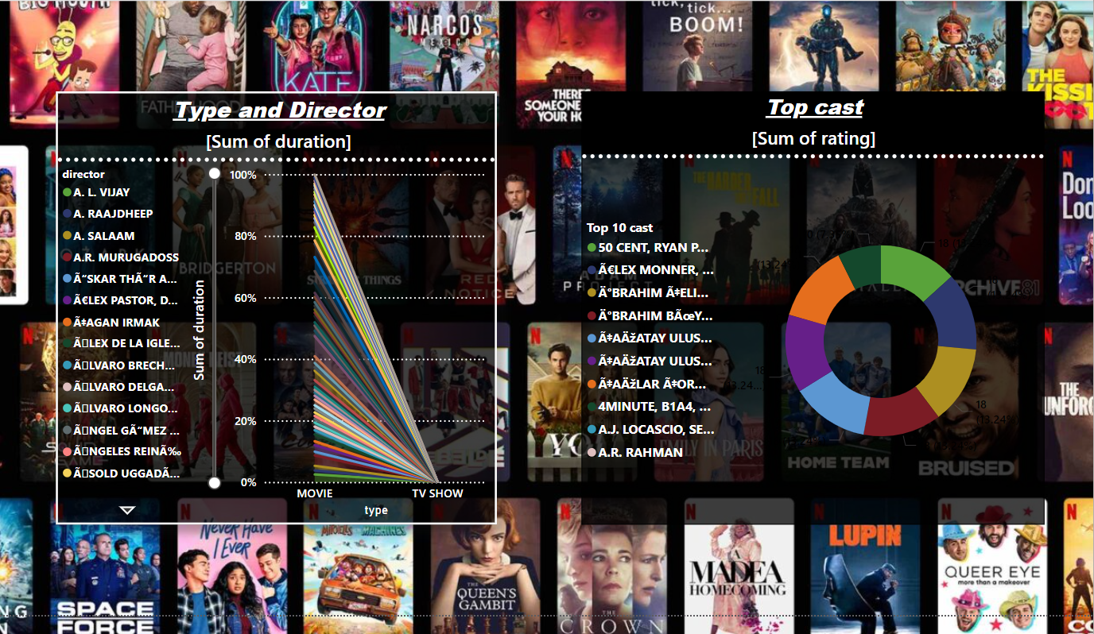

**Left Chart: Type and Director (Stacked Line Chart)**

* **Chart Type**: This is a **stacked line chart** that shows the **sum of the duration** (possibly in minutes or episodes) of content directed by various directors. Each director is listed on the left side of the chart, and their contributions are divided between **movie** and **TV show** categories. Each line represents a different director, showing the proportion of their work across the two types of media.
* **Motive of the Chart**: This chart is used to analyze the distribution of content created by different directors, comparing their involvement in movies versus TV shows. It highlights which directors are more associated with either medium, providing insight into their focus areas. The motive could be to identify director performance in terms of volume of work, split between movies and TV shows, helping content managers understand directorial strengths and preferences.

**2. Right Chart: Top Cast (Donut Chart)**

* **Chart Type**: This is a **donut chart**, representing the **top 10 cast members** based on the **sum of ratings** (which could refer to user ratings or average ratings of shows/films they have acted in). Each segment corresponds to a different cast member, displaying their share of the total ratings.
* **Motive of the Chart**: The purpose of this chart is to showcase which cast members are contributing the most to highly rated Netflix content. By visualizing cast members' influence on top-rated content, this chart highlights popular or successful actors that have a positive impact on show/film ratings, offering valuable insight for casting decisions or audience engagement.

**Overall Insight:**

Together, these charts offer insights into **content creation and performance** on Netflix. The left chart focuses on **director contributions** to different types of content (movies vs. TV shows), while the right chart analyzes the **impact of top actors** on the overall ratings of content. The goal of this visualization is to help decision-makers in the media industry better understand the influence of directors and actors on Netflix's platform, thereby guiding strategic decisions in content production and casting.

***VISUALISATION 4)***

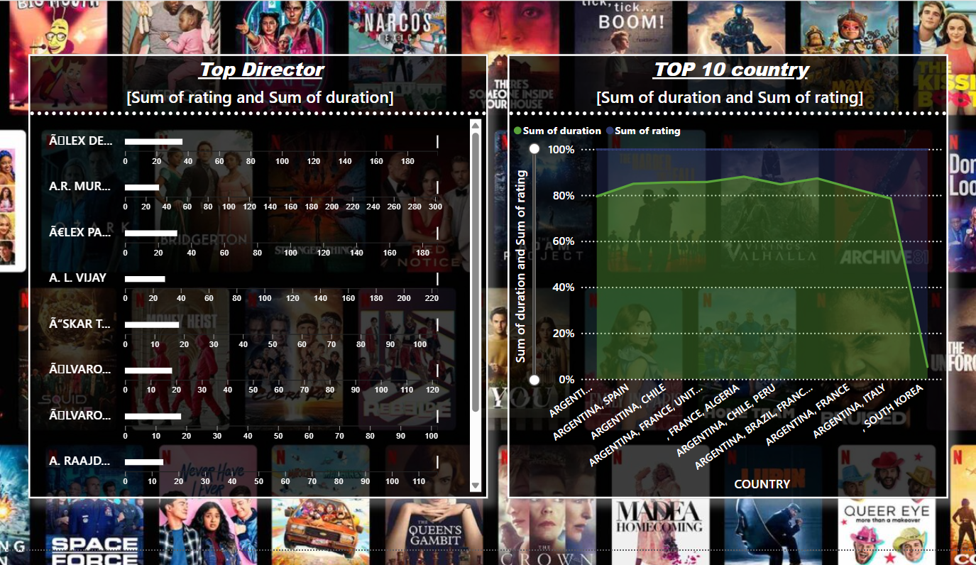

**1. Left Chart: Top Director (Horizontal Bar Chart)**

* **Chart Type**: This is a **horizontal bar chart** that represents the **sum of ratings** and **sum of duration** for each director. Each bar displays how much content (in terms of duration) has been directed by different individuals and how well those contents have been rated by viewers.
* **Motive of the Chart**: This chart’s primary purpose is to showcase the contribution of top directors to Netflix's content library, both in terms of quantity (duration) and quality (ratings). By doing so, the chart allows stakeholders to identify directors who are not only prolific but also deliver high-quality content that resonates with viewers. This analysis can be used to spot trends and make strategic decisions regarding future collaborations or content investments with specific directors who drive both engagement and positive feedback.

**2. Right Chart: Top 10 Country (Area Line Chart)**

* **Chart Type**: This is an **area line chart** that depicts the **sum of duration and sum of ratings** for content produced in the top 10 countries. The x-axis lists the countries, while the y-axis represents the combined sum of the two metrics, with the line chart showcasing the overall trend.
* **Motive of the Chart**: The aim of this chart is to provide insights into which countries are contributing the most to Netflix's catalog both in terms of content volume (duration) and quality (ratings). It gives a clear picture of geographic trends, highlighting the nations whose content is both abundant and well-received. This could guide decisions on where Netflix may want to focus its international production efforts or which markets might be emerging as strong sources of content for global consumption.

**Overall Insight:**

Together, these charts provide a comprehensive overview of Netflix’s content from both a **creative** (director) and **geographic** (country) perspective. The **Top Director** chart emphasizes individual contributions in terms of content creation and ratings, while the **Top Country** chart highlights how different nations are influencing Netflix’s library based on production volume and audience reception. These insights can help drive strategic decisions related to talent acquisition, regional focus, and content partnerships.

***VISUALISATION 5)***

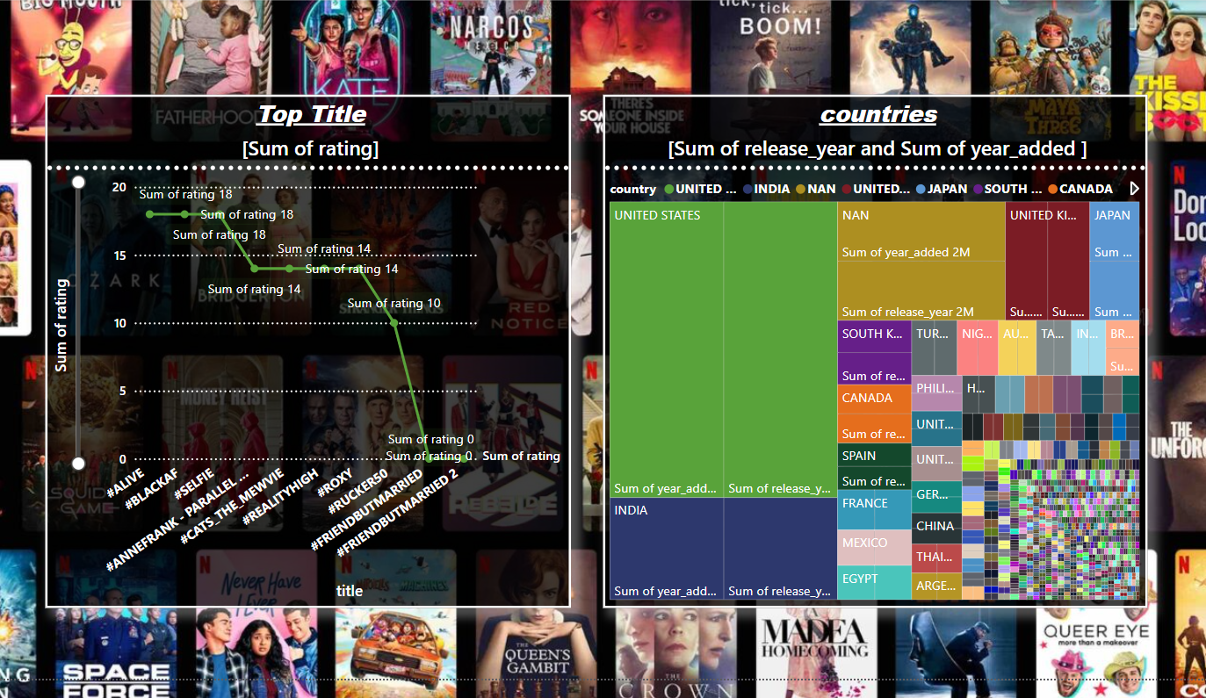

This visualizes Netflix data analysis, using a combination of charts to display key metrics such as top-rated titles and country-wise distribution of releases.

On the left side, we have a **line chart** labeled “Top Title [Sum of Rating],” which represents Netflix titles ranked by their aggregated user ratings. Each point on the line corresponds to a specific title, with the Y-axis showing the total sum of ratings and the X-axis listing titles. The green line connecting these points shows the relationship between various titles and their popularity. The purpose of this chart is to highlight the most popular Netflix content based on audience ratings, making it easy to identify which titles received the highest engagement and satisfaction.

On the right side, a **treemap chart** titled "Countries [Sum of Release Year and Sum of Year Added]" visually represents the contribution of different countries to the Netflix catalog. Each block within the treemap shows the sum of the year of release and year added, categorized by country, with the size of each block corresponding to the volume of releases from that country. The United States clearly dominates the chart, followed by other key countries such as India, the United Kingdom, and Japan. This treemap chart helps provide an understanding of content diversity on Netflix, showing which countries contribute the most content over time.

Together, these visualizations aim to provide insights into the most popular titles based on user engagement and how Netflix's content library has grown over the years, segmented by countries. This analysis allows Netflix or stakeholders to understand global content distribution trends and audience preferences.

***VISUALISATION 6)***

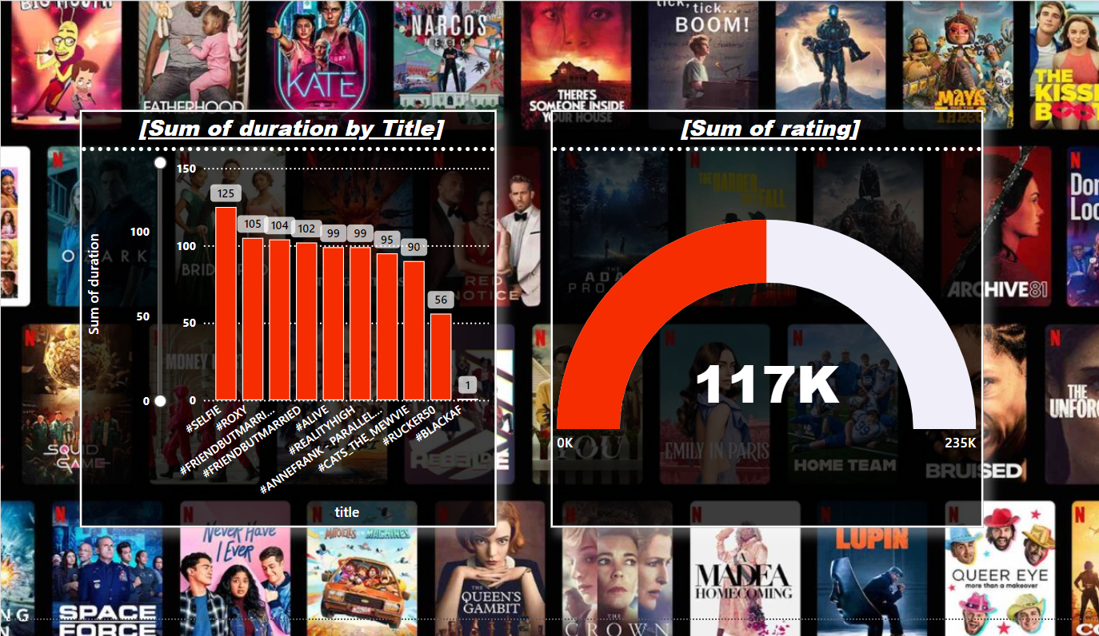

In this Power BI visualization of Netflix data analysis, two distinct charts represent different aspects of content consumption and ratings.

On the left, we see a **bar chart** titled "Sum of Duration by Title." This chart shows the total duration of various Netflix titles, where each bar corresponds to a specific title with the Y-axis representing the total sum of its duration. The labels on top of each bar (e.g., 125, 105, etc.) provide the exact duration value in minutes. Titles like "#SELFIE," "#BROX," and "#FRIENDBUTMARRIED" have some of the highest durations, indicating either longer films or series with multiple episodes. The purpose of this chart is to visualize the time commitment for each title, helping viewers or analysts assess how much content Netflix offers in terms of viewing hours for its most popular titles.

On the right is a **gauge chart** titled "Sum of Rating," which shows the cumulative total of all ratings for the selected Netflix titles. The value "117K" is prominently displayed in the center, indicating the sum of ratings out of a possible maximum of "235K," which is displayed on the right side of the gauge. The gauge format effectively visualizes how close the total ratings are to a target or maximum value, making it easy to gauge the level of engagement and popularity of Netflix titles at a glance.

Overall, the combination of these two charts provides insights into both the volume of content in terms of duration (left chart) and user engagement in terms of ratings (right chart), giving a holistic view of Netflix content performance and viewer reception. This is useful for content strategists to balance the duration of content offered with user satisfaction and ratings.

***VISUALISATION 7)***

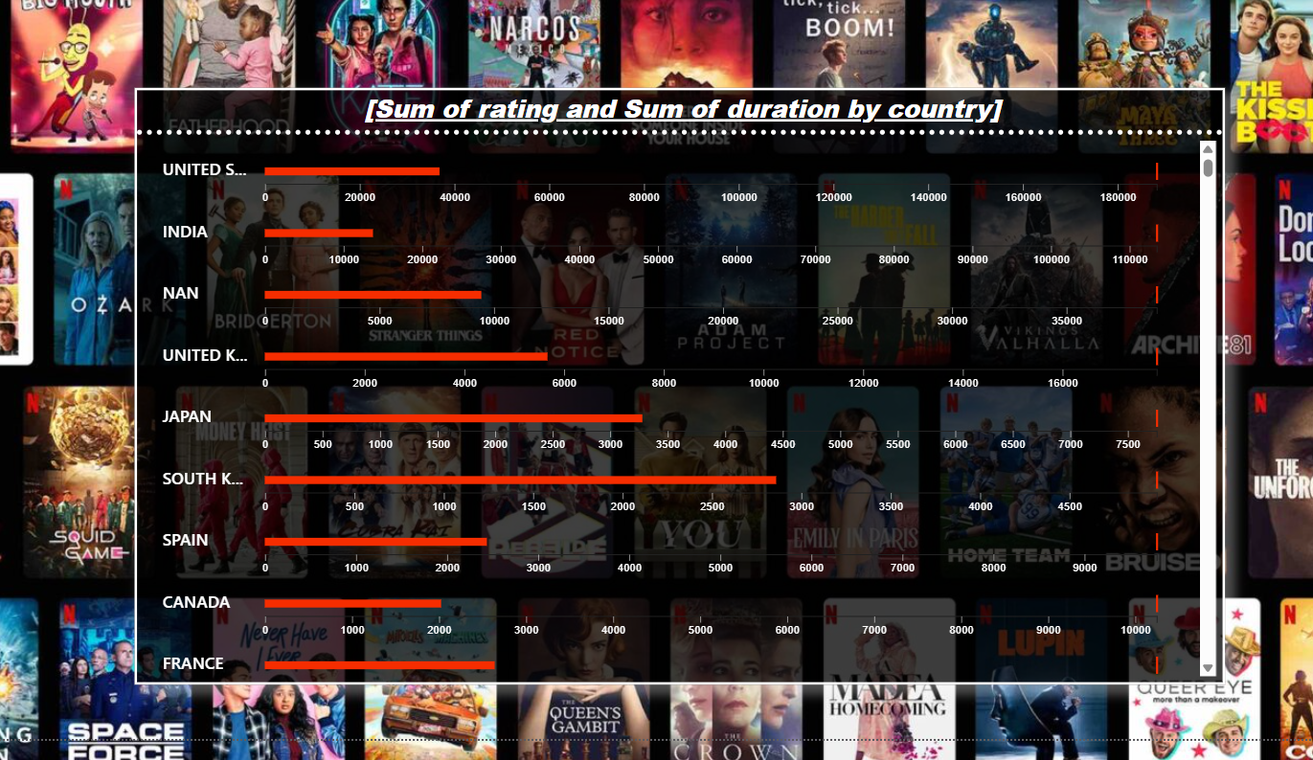

In this Power BI visualization, we are looking at a **clustered bar chart** titled "Sum of Rating and Sum of Duration by Country." The chart represents two key metrics for Netflix content from different countries: the total sum of user ratings and the total viewing duration of titles. Each horizontal bar corresponds to a specific country, such as the United States, India, Japan, and others, with two bars for each country—one for the sum of ratings and one for the sum of content duration. The X-axis indicates the magnitude of both metrics, with larger values showing higher engagement or content volume from that country.

The United States, as shown, leads in both ratings and content duration, implying that it contributes the most content in terms of hours watched and receives high user engagement. Other countries like India, the United Kingdom, Japan, and South Korea also show considerable contributions but to a lesser degree.

The motive of this chart is to compare the performance and presence of Netflix content by country, allowing stakeholders to understand how different regions contribute to the platform's overall content library and how well that content resonates with the audience. This comparison provides insights into both the volume of content available from each country and its popularity, helping guide future investments in content production and acquisition in specific regions.

***VISUALISATION 8)***

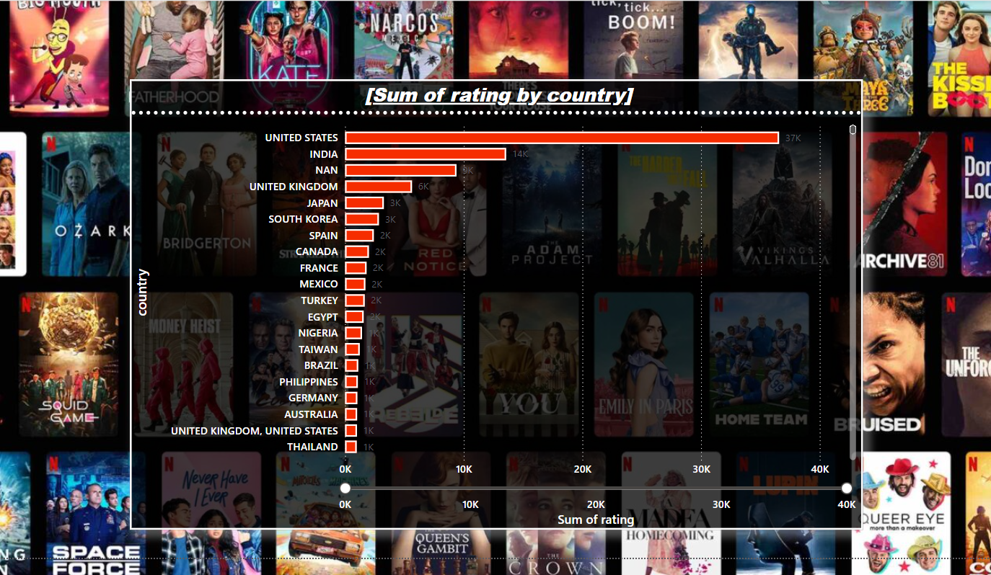

The visualization presented is a **horizontal stacked bar chart**, often used to compare categorical data across different groups. In this case, the chart illustrates the **sum of Netflix ratings by country**, where each bar represents the total ratings accumulated by Netflix users from a specific country. The countries are listed on the y-axis, while the x-axis represents the sum of ratings.

The visual conveys that the **United States** has the highest accumulated rating, followed by **India** and other countries, with notable contributions from the **United Kingdom**, **Japan**, and **South Korea**. The label "NAN" in third place likely represents missing or unclassified data.

The chart's motive is to highlight the **distribution of Netflix ratings across different countries**, giving insights into the geographic concentration of viewership and engagement. This information is valuable for content creators and platform managers to understand where their services are most popular and potentially adjust their strategies based on regional engagement patterns. It visually communicates the disparity between countries like the U.S., which has significantly higher ratings, and others with lower engagement, offering opportunities for deeper analysis into why certain countries outperform others in terms of ratings.

This visualization is particularly effective because it clearly represents a comparison between countries in terms of user activity and content reception, making it easy for the audience to grasp the global influence on Netflix’s ratings.

***VISUALISATION 9)***

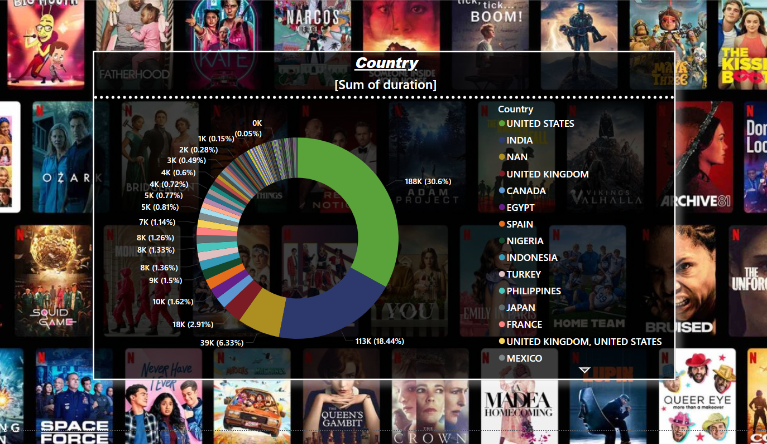

The visualization displayed is a **donut chart**, which is an advanced form of a pie chart. This chart is used to show the **sum of duration (viewing time)** by country on Netflix, illustrating the proportional breakdown of total viewing time contributed by each country. The large segments represent the countries with the highest viewing durations, while the smaller segments indicate countries with lesser contributions. The donut shape allows for better clarity and space to add textual information within the hollow center, which can be used for data labels or additional explanations.

The largest segment, marked as **188K (30.6%)**, represents the **United States**, showing that this country accounts for over 30% of the total viewing duration on Netflix. The next significant contributors include **India** with 113K (18.44%) and other countries listed with decreasing percentages. There is also a notable segment labeled "NAN," indicating potentially missing or unclassified data.

The motive behind this chart is to provide a **clear visual comparison of the total time users from different countries spend on Netflix**. This chart helps stakeholders understand where the most engaged audiences are located in terms of time spent on the platform. By focusing on total viewing duration, the visualization offers insights into which regions might be more invested in long-form content or binge-watching, as opposed to focusing solely on ratings or other metrics. This data can be used to inform content strategies, marketing decisions, and even server optimization based on where the most significant demand for streaming time is coming from.

***VISUALISATION 10)***

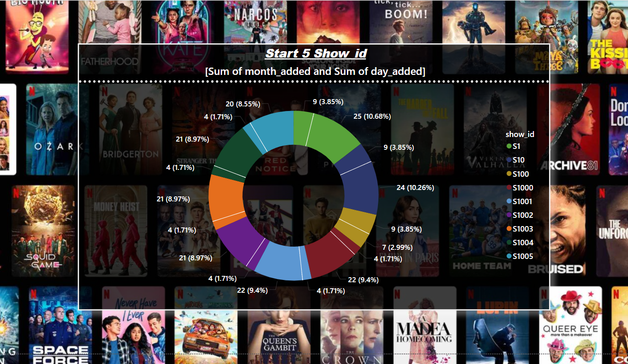

The visualization shown is a **donut chart**, similar to a pie chart but with a hollow center. It displays the **distribution of show IDs** based on the **sum of the month and day when they were added to Netflix**. Each colored segment represents a different show ID, with the corresponding percentages labeled outside the chart. The chart provides a clear breakdown of the frequency with which different show IDs have been added to the Netflix catalog, showcasing patterns in content addition over time.

The chart's main motive is to represent the **distribution of show releases over time**, highlighting which show IDs have been added more frequently or during specific periods. For instance, show ID S1000 (marked in orange) makes up **10.26%** of the total, showing a significant number of additions for that particular show ID, while others like S1005 or S1 show smaller contributions.

The motive of this donut chart is to provide insights into the **content release pattern on Netflix**, helping stakeholders understand trends in content addition. This visualization can be used to identify which shows or series IDs are being frequently added to the platform, possibly reflecting popular shows or those with multiple seasons. It could also be useful for identifying time periods (by months and days) when Netflix sees a surge in content uploads. Overall, this chart helps track Netflix's catalog management and content update strategy.

***VISUALISATION 11)***

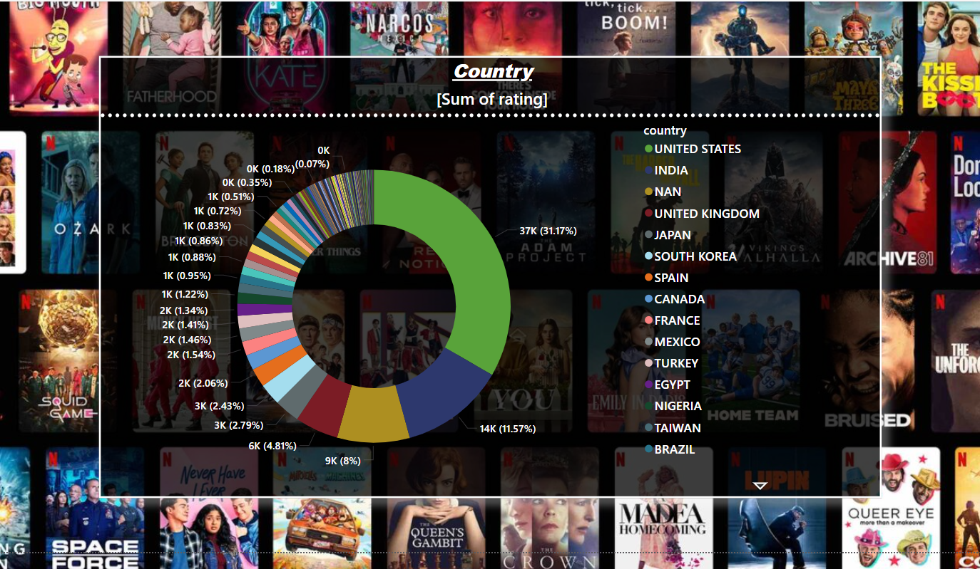

This Power BI visualization is a **Donut/Pie Chart** that provides an analysis of Netflix ratings data segmented by country. The chart's main purpose is to show the proportion of ratings received by content from different countries, represented as slices of ` donut chart, with the size of each slice corresponding to the sum of ratings for that country. The United States, clearly the largest contributor (31.17% of ratings), is followed by other countries like India, the United Kingdom, Japan, and South Korea, among others. Each country is color-coded to distinguish it, and the legend on the right side lists these countries for reference.

The primary motive behind this visualization is to highlight the distribution of Netflix content ratings across various countries, allowing for insights into which countries' content is most consumed or highly rated on the platform. This type of chart is beneficial for understanding geographical trends in audience preferences, identifying key markets, and assessing the global reach of Netflix's content library. The additional text labels within the donut chart show detailed rating counts for each country, providing a clear numerical context alongside the visual proportions. By focusing on the "Sum of rating" per country, this chart helps stakeholders gauge the global engagement of Netflix users and informs decisions on content investments and marketing strategies.

***VISUALISATION 12)***

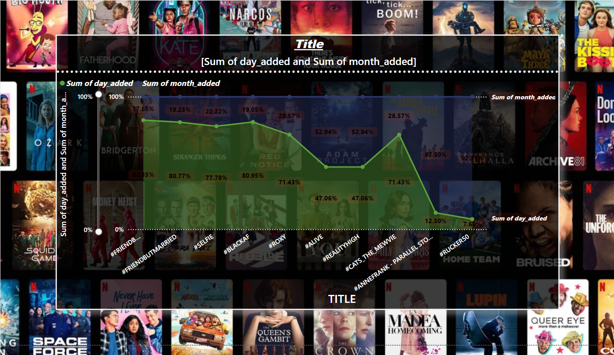

This Power BI visualization is a **Dual-Axis Line Chart** displaying the "Sum of Day Added" and "Sum of Month Added" for different Netflix titles. The green line represents the "Sum of Day Added," while the blue line corresponds to the "Sum of Month Added." Both lines provide a comparative look at how these two metrics vary across different shows or titles. The x-axis lists the titles, mostly represented by hashtags, while the y-axis shows the values for each metric.

The chart's primary purpose is to illustrate how frequently content was added to Netflix based on two time frames: daily and monthly. By using two lines on the same chart, the viewer can easily spot differences in trends between short-term (daily) and longer-term (monthly) content additions. For example, certain titles have high "Sum of Month Added" percentages, indicating that content was likely added or updated more frequently during specific months. On the other hand, the green line shows how often titles were added or updated on a daily basis, which varies significantly for different shows.

The motive behind this visualization is to identify content upload or addition patterns and assess whether certain shows are updated more regularly in a given time frame. It is useful for determining how often content gets refreshed on the platform and understanding the popularity or demand trends based on when titles were added to the library. This can help Netflix gauge its content release strategy and optimize scheduling for adding new titles or updating existing ones.

***DASHBOARD:***

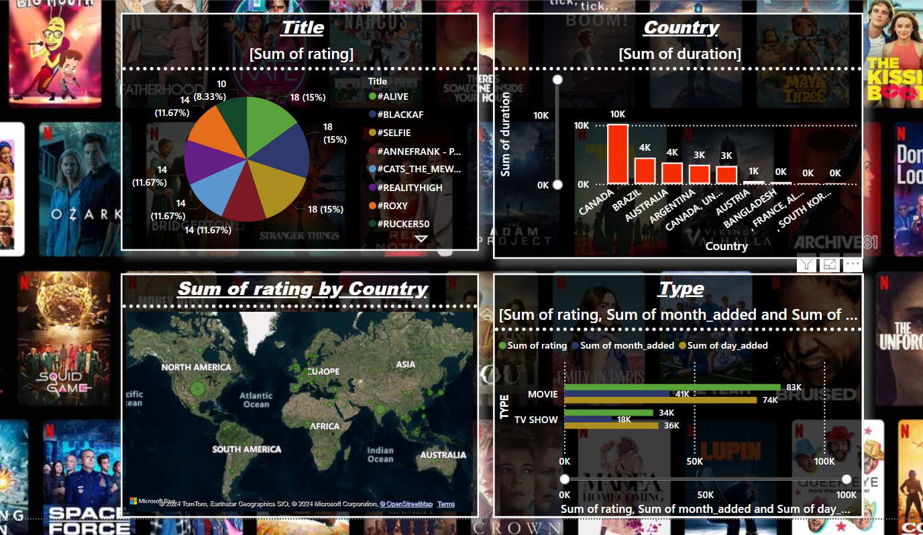

This Power BI dashboard is a combination of multiple visualizations representing various aspects of Netflix data analysis. The visualizations include a **Pie Chart**, **Bar Chart**, **Map Chart**, and a **Stacked Bar Chart**. Each one serves a unique purpose:

1. **Pie Chart (Top Left)** - It shows the **Sum of Rating** by Title, where different colors represent different Netflix shows (like #ALIVE, #BLACKAF, etc.), and the percentages represent the proportion of ratings each show received. The primary motive here is to visualize the distribution of ratings across various popular titles, making it easy to see which ones are most highly rated or consumed.
2. **Bar Chart (Top Right)** - This chart displays the **Sum of Duration** by Country, with bars representing the total amount of content duration from different countries. The larger the bar, the more content hours are available from that country. This is useful for analyzing which countries produce the most content in terms of screen time, helping stakeholders understand content investment distribution.
3. **Map Visualization (Bottom Left)** - The **Map Chart** shows the **Sum of Rating by Country**, with data points scattered across different continents. Each green circle represents the number of ratings, and its size reflects the sum of ratings for that specific country. This map gives a geographical perspective of where Netflix's ratings come from, highlighting the platform’s global reach and identifying key market areas.
4. **Stacked Bar Chart (Bottom Right)** - This visualization is a **Stacked Bar Chart** showing the **Sum of Rating, Sum of Month Added, and Sum of Day Added** by Type (Movie and TV Show). It gives a comparative look at the volume of movies versus TV shows in terms of ratings and how often content is added to the platform daily and monthly. The stacked bar format allows viewers to easily compare both content types and track their release frequency and user engagement.

Overall, the motive of this dashboard is to provide a comprehensive overview of Netflix's content performance across different dimensions such as content type, country, duration, and ratings. It offers insights into global consumption trends, content variety, and audience preferences, aiding in strategic decision-making regarding content production, marketing, and release scheduling.

***GETTING BACK TO PYTHON, FOR THE CREATION OF RECOMMENDATIONS SYSTEM OF TITLES, BASED ON RATINGS.***

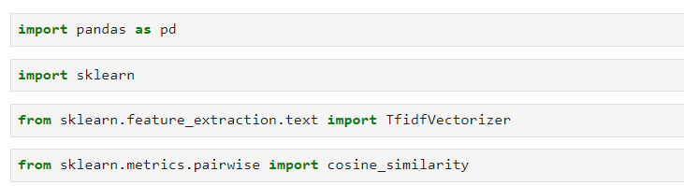

This section of the code is essential for loading the necessary libraries and modules to build the recommendation system. The first line imports the pandas library, which is crucial for data manipulation and analysis. pandas provides data structures like DataFrames, which allow us to load and work with the Netflix dataset efficiently, enabling operations like filtering, replacing missing values, and extracting relevant columns (such as movie titles and ratings). The second import statement brings in the sklearn library, which is a robust set of machine learning tools for data preprocessing, model building, and evaluation.

In particular, the TfidfVectorizer from sklearn.feature_extraction.text is imported to convert the text data (movie titles) into numerical form. This step is critical because machine learning models can only work with numerical data, and the TF-IDF (Term Frequency-Inverse Document Frequency) technique helps to measure the importance of words within a document relative to a collection of documents (in this case, movie titles). Finally, the cosine_similarity function is imported from sklearn.metrics.pairwise, which is used to calculate the similarity between vectors, allowing us to measure how closely related different movie titles are based on their text representations.

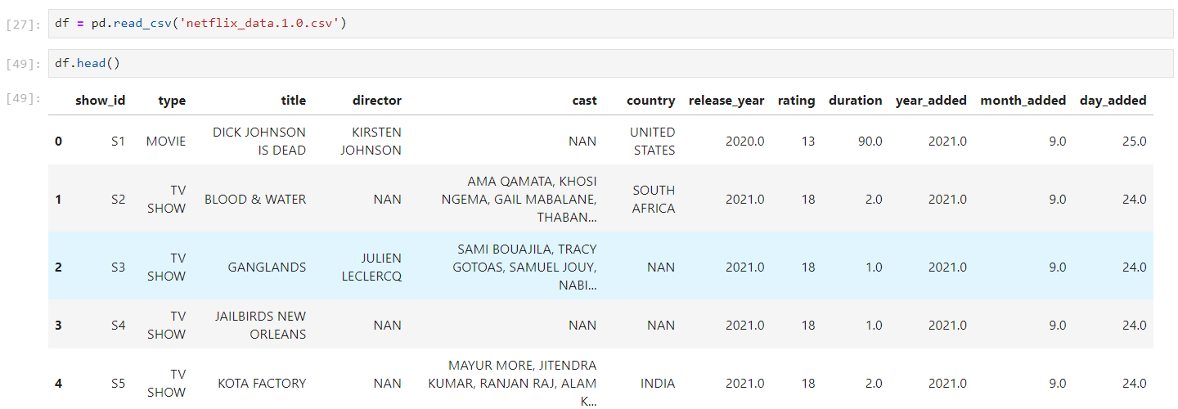

In this part of the code, the Netflix dataset is loaded into a DataFrame using the pd.read_csv() function from the pandas library. The file, "netflix_data.1.0.csv", contains various attributes related to the Netflix titles such as show_id, type, title, director, cast, country, release_year, rating, duration, and the date when it was added to the platform. By calling df.head(), the first few rows of the dataset are displayed, which gives an overview of the content and structure of the data. Each row corresponds to a particular title (movie or TV show), with different metadata about that title, like its genre, director, cast members, country of origin, and user ratings. Some of the cells have missing values (NaN), such as in the director and cast columns, which will need to be handled in subsequent steps (for example, filling in missing ratings or titles as part of data preprocessing). This is the starting point for building a recommendation system by using the title and rating data from this dataset.

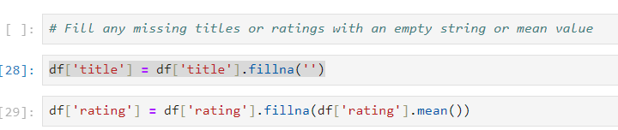

This block of code addresses the issue of missing data, which is a common problem in real-world datasets. Specifically, it deals with missing values in the title and rating columns. The first line, df['title'].fillna('', inplace=True), fills any missing entries in the title column with an empty string (''). This ensures that there are no NaN (Not a Number) values in the title field, which is essential for text-based operations like vectorization. If the missing values were left as NaN, it could cause issues later when the TF-IDF vectorizer tries to process the title column, as the model expects non-empty text data.

The second line, df['rating'].fillna(df['rating'].mean(), inplace=True), handles missing values in the rating column by replacing them with the mean rating of the entire dataset. This is a common technique called imputation, where the mean of the existing ratings is used as a substitute for missing values. This method ensures that the absence of ratings does not negatively affect the analysis or recommendations. By filling in the missing ratings with a representative value, the model can still use the rating data to filter recommendations without the risk of errors or biases from incomplete data.

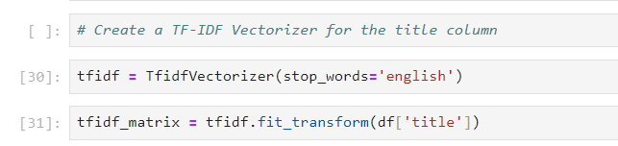

This section of the code uses the TfidfVectorizer to transform the movie or show titles from the dataset into a numerical format that can be used for similarity analysis. TF-IDF stands for Term Frequency-Inverse Document Frequency, a technique that quantifies the importance of words within a set of documents (in this case, movie titles) by assigning higher weights to less common words and lower weights to frequent ones. The line tfidf = TfidfVectorizer(stop_words='english') initializes the vectorizer, where the argument stop_words='english' ensures that common English words like "the," "and," or "is" are ignored because they don’t contribute meaningful information to the recommendation system.

Next, tfidf_matrix = tfidf.fit_transform(df['title']) applies the TF-IDF vectorizer to the movie titles, converting each title into a vector of numerical values representing word importance. The resulting tfidf_matrix is a sparse matrix where each row corresponds to a movie title, and each column represents a unique word from the corpus of titles. This matrix is crucial for the next step, where cosine similarity is computed between titles to identify which ones are most similar based on their textual content. By using TF-IDF, the system captures the unique aspects of each title, making it possible to recommend movies with similar themes or titles.

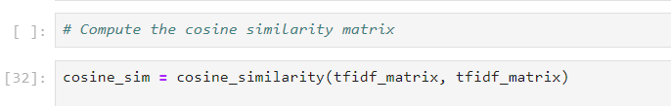

This line of code, cosine_sim = cosine_similarity(tfidf_matrix, tfidf_matrix), calculates the cosine similarity between all pairs of movies or show titles in the dataset. Cosine similarity is a measure of how similar two vectors are, based on the angle between them. In the context of this project, each title has been transformed into a vector using the TF-IDF technique, where each vector represents the unique word composition of that title. The cosine similarity score ranges from -1 to 1, with 1 indicating perfect similarity (i.e., the two titles are exactly the same in terms of word usage), and 0 indicating no similarity. Negative values, though rare in this context, would indicate opposite meanings.

By passing tfidf_matrix twice as arguments, this line computes the pairwise cosine similarity between every title and every other title in the dataset, resulting in a similarity matrix. Each entry in this matrix represents the similarity score between two titles. This matrix is critical for the recommendation system because it allows the algorithm to find titles that are most similar to a given movie or show. When a user searches for a particular title, the recommendation system can refer to this similarity matrix to identify and suggest other titles with similar textual content. This makes the system effective in recommending related or similar movies and shows based purely on title analysis.

c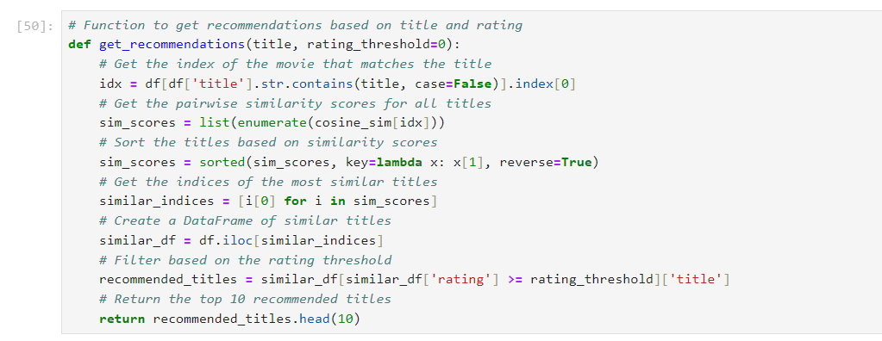

The get_recommendations function is designed to generate a list of movie recommendations based on a specified title and a user-defined rating threshold. The function begins by locating the index of the movie that matches the input title using the Pandas str.contains() method. This allows for case-insensitive matches, enhancing user experience by accommodating variations in title casing. Once the index is determined, the function retrieves the cosine similarity scores for the selected movie against all other titles in the dataset. Cosine similarity measures how similar two movies are based on their textual representations, effectively allowing the recommendation system to suggest movies that are thematically or contextually similar to the given title.

After obtaining the similarity scores, the function sorts them in descending order, ensuring that the most similar titles appear first. The indices of these titles are then extracted and used to create a subset of the original DataFrame, similar_df, which contains only the top matches. To refine the recommendations further, the function filters this subset based on the specified rating threshold, ensuring that only movies with ratings equal to or higher than the threshold are considered. Finally, the function returns the top 10 recommended titles from this filtered list, providing users with a concise selection of films that align closely with their preferences based on both similarity and quality ratings. This approach effectively combines textual analysis and user-driven rating metrics to enhance the movie recommendation process.

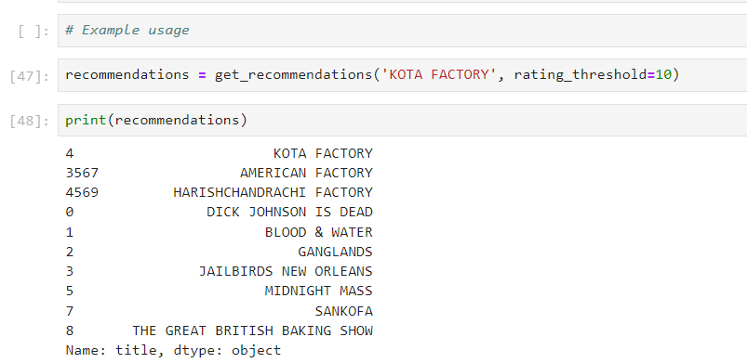

The line recommendations = get_recommendations('KOTA FACTORY', rating_threshold=10) calls the get_recommendations function, providing it with the title "KOTA FACTORY" and setting a rating threshold of 10. This means that the function will search for movies similar to "KOTA FACTORY" while only considering those that have a rating of 10 or higher. Upon execution, the function processes the input title by locating its index in the dataset, calculating cosine similarity scores with other titles, and filtering the results based on the specified rating criteria. The resulting recommendations are then stored in the variable recommendations. The subsequent line, print(recommendations), outputs this list of recommended movie titles to the console, allowing the user to see which films align with their interest in "KOTA FACTORY" and meet the specified rating requirement. This process demonstrates how the recommendation system leverages both textual similarity and user-defined quality metrics to generate personalized suggestions.

***OTHER EXAMPLES ARE:***

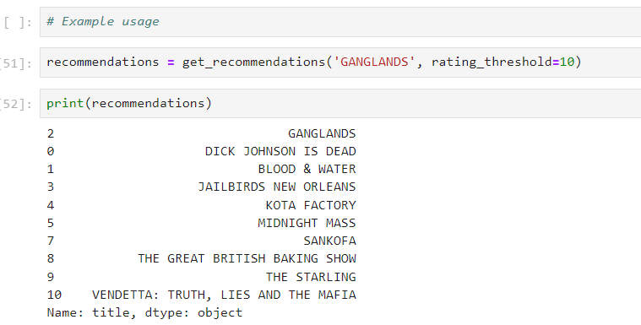

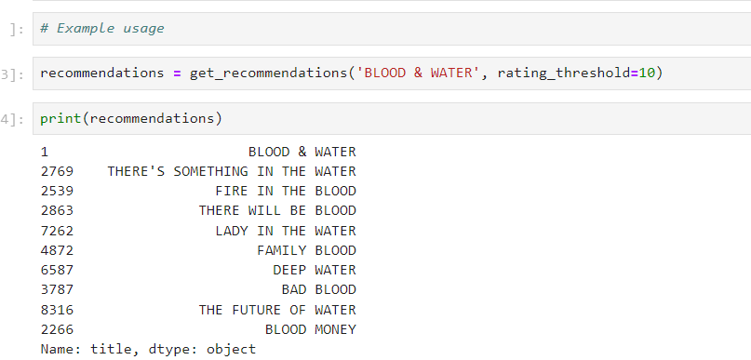

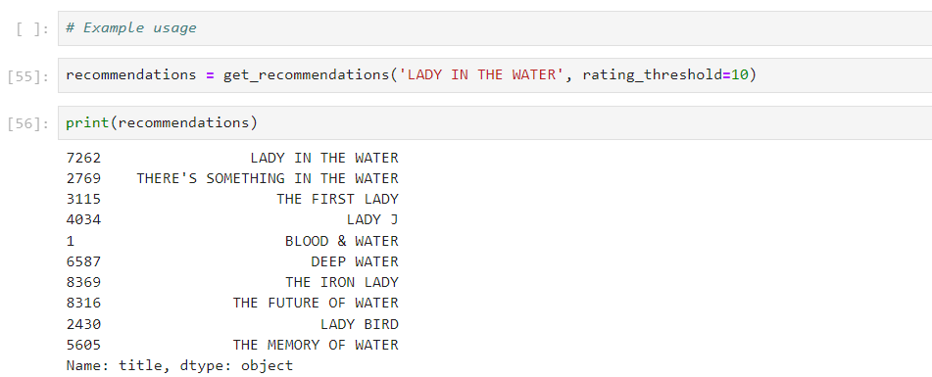

***ALGORITHM***

***[CONTENT-BASED FILTERING ALGORITHM]***

n this recommendation system, the **algorithm used is based on **Content-Based Filtering** through **Cosine Similarity**. The system uses the textual data from the movie or TV show titles and computes similarity between them using the **TF-IDF (Term Frequency-Inverse Document Frequency)** technique for text vectorization. The core idea of the algorithm is to recommend titles that are similar in content (based on their textual descriptions, in this case, the title of the show or movie).

1. **TF-IDF (Term Frequency-Inverse Document Frequency)**:
   * The first part of the recommendation system involves the use of **TF-IDF**, a widely used method in Natural Language Processing (NLP) to convert textual data into numerical features. The basic idea of TF-IDF is to represent text (like the title of a movie) by giving higher weights to words that are important (unique) and lower weights to common words that appear frequently in many titles.
   * **TF (Term Frequency)** measures how frequently a term (word) appears in a document (title) relative to the total number of words in that document. The more frequent a word is, the higher the TF score.
   * **IDF (Inverse Document Frequency)** gives more importance to words that are rare across the whole dataset and discounts words that are very common. The formula for IDF is the logarithm of the total number of documents divided by the number of documents that contain the term.
   * In this system, the TfidfVectorizer from sklearn is used to convert the titles into vectors of numerical values that represent the importance of each word in the context of all other titles.
2. **Cosine Similarity**:
   * Once the titles are converted into TF-IDF vectors, the algorithm uses **Cosine Similarity** to compute how similar two vectors (titles) are to each other. Cosine similarity is a metric used to measure the similarity between two non-zero vectors of an inner product space by calculating the cosine of the angle between them. It is widely used in recommendation systems because it measures the orientation of the vectors (i.e., how close they are), rather than their magnitude.
   * The result of the cosine similarity computation is a matrix where each element represents the similarity score between two titles. A score of **1** indicates perfect similarity, while a score closer to **0** means there is little or no similarity between the titles.
   * This similarity matrix is then used to sort and rank the most similar titles when a user inputs a title for which they need recommendations.
3. **Content-Based Filtering**:
   * This system employs **content-based filtering**, meaning the recommendations are based solely on the content (i.e., the title) of the item being analyzed. It does not take into account user behavior (like ratings given by users), but instead, it looks at the similarity between items based on their features (in this case, the titles of shows or movies).
   * When the function get_recommendations() is called with a particular title (e.g., "KOTA FACTORY"), it identifies titles that are most similar to the input title based on the cosine similarity scores. The optional rating_threshold parameter allows for filtering the recommendations further based on their ratings, ensuring that only titles with a rating above a certain threshold are suggested.

Overall, this recommendation system is a **content-based filtering model** that uses **TF-IDF vectorization** to represent text and **cosine similarity** to find similar titles. It provides recommendations based on textual similarities and is particularly useful for generating recommendations for similar movies or shows based on their titles.

***Future Enhancements for Netflix Data Analysis Project:***

1. **Incorporation of Real-time Data**:
   * Currently, the analysis is likely based on static datasets. A future enhancement could be the integration of real-time Netflix data through APIs or web scraping techniques. This would allow for continuous updates and make the insights more relevant for current trends.
2. **Personalized Recommendation Engine**:
   * A major upgrade could be building a recommendation engine using collaborative filtering or content-based filtering. By analyzing user preferences, watch history, and ratings, personalized movie and TV show suggestions can be generated, enhancing user engagement.
3. **Sentiment Analysis on Reviews**:
   * Applying natural language processing (NLP) techniques to analyse user reviews and comments on movies and TV shows could provide insights into viewer satisfaction, helping predict popular trends and the likelihood of a show or movie’s success.
4. **Enhanced Visualizations with Machine Learning Insights**:
   * Future iterations can integrate machine learning models that predict success factors for movies based on genres, actors, and ratings. These insights could be visualized through more advanced data visualization tools like interactive dashboards, making the data more user-friendly and actionable.
5. **Analysis of Global Trends**:
   * Expanding the scope of analysis to include how Netflix content is consumed globally, examining factors such as cultural preferences and regional popularity. This would involve incorporating more granular location-based data to identify market-specific content preferences.
6. **Predictive Analysis for Viewer Retention**:
   * Implementing predictive analytics to forecast trends in viewer behavior, especially related to churn rate or content popularity. This can help Netflix understand which genres or shows keep viewers subscribed and adjust content strategies accordingly.
7. **Incorporation of Subscription and Revenue Data**:
   * By adding financial data such as subscription trends and revenue associated with specific content, the analysis could extend to understanding the economic impact of different shows, helping to forecast future profitability.

***Conclusion of the Project:***

The Netflix data analysis project has provided significant insights into the consumption patterns, preferences, and overall trends within the platform. Through a detailed exploration of data regarding movies, TV shows, genres, ratings, and other critical factors, we can observe how Netflix content appeals to various audience segments globally. The analysis successfully highlights patterns in content preferences, such as the prominence of certain genres and the growing trend of international content becoming popular across diverse regions. This gives a clear indication of the dynamism and evolving nature of the entertainment landscape.

Moreover, this project underscores the value of data-driven decisions for a streaming giant like Netflix. By analyzing viewer ratings, release dates, and content distribution, this project offers Netflix actionable insights into which content categories garner the most engagement and viewer retention. It becomes evident that, for a platform thriving on subscriptions, maintaining an expansive yet carefully curated library of content is essential. Such an analysis also illustrates the importance of creating and acquiring content that resonates with both local and global audiences.

Looking forward, this project has laid a strong foundation for further enhancement. With the implementation of machine learning algorithms, Netflix could optimize its recommendation systems to provide users with personalized content suggestions. In addition, by delving into global content trends and viewer sentiment analysis, Netflix can predict what future content is likely to succeed. This ability to anticipate viewer demand and adapt to shifting preferences is vital for the platform’s sustained growth and innovation.

In conclusion, Netflix continues to be a leader in the entertainment industry due to its strategic use of data and analytics. This project, by dissecting and understanding these trends, contributes valuable insights that not only reflect Netflix's current success but also point to areas for future improvement. With advanced data analytics, Netflix can further solidify its position in a competitive market, enhancing both viewer satisfaction and business outcomes.